

**Informatics Institute of Technology**

**University of Westminster**

**Software Development Group Project**

**5COSC021C.Y**

**CS - 75**

|  |  |
| --- | --- |
| **Student Name** | **Student UoW ID/ IIT ID** |
| Ometh Welihinda | w2051653 / 20230383 |
| Vihanga Rathnasekera | w2051680 / 20230505 |
| Tharindu Madushanka | w2052209 / 20232113 |
| Anju Gunathilaka | w2051655 / 20230387 |
| Chamith Wijewantha | w2052169 / 20231564 |
| Dhanushi Arachchi | w2051668 / 20230443 |

Declaration Page

I hereby declare that this project titled **"AI-Enhanced Job Interview Simulation Platform"** is my original work and has not been submitted elsewhere for the award of any degree or diploma. All the information contained in this document has been obtained and presented as per academic and ethical guidelines. Where work from other sources has been used, proper references and citations have been provided.

**Name:** Anju Gunathilaka  
**IIT ID:** 20230387  
**UoW ID:** w2051655

**Name:** Ometh Welihinda  
**IIT ID:** 20230383  
**UoW ID:** w2051653

**Name:** Dhanushi Arachchi  
**IIT ID:** 20230443  
**UoW ID:** w2051668

**Name:** Chamith Wijewantha  
**IIT ID:** 20231564  
**UoW ID:** w2052169

**Name:** Tharindu Madushanka  
**IIT ID:** 20232113  
**UoW ID:** w2052209

**Name:** Vihanga Rathnasekera  
**IIT ID:** 20230505  
**UoW ID:** w2051680

Abstract

The project presents an AI-enhanced interview simulation platform intended to assist job candidates in preparing for professional interviews through the real-time display of scoring metrics and interactive feedback. The platform employs AI technologies at an advanced level, such as natural language processing and sentiment analysis, in evaluating and analyzing candidate responses. Among key functionalities: the analysis of voice and video; postures and facial expressions; grammar check and relevance of response; personal feedback generation. This is a modular platform designed in a layered architecture, which is scalable and maintainable. The project focuses exclusively on candidate-facing features, hence providing an innovative solution to help people improve their interview performance.

**Keywords** AI-powered platform, job interview simulation, layered architecture, candidate evaluation, real-time feedback, sentiment analysis, posture evaluation.

Acknowledgement

We, the team members, would like to take this opportunity to collectively extend our most heartfelt appreciation to every person who helped guide and support us through the process of building our project, AI Enhanced Job Interview Simulation Platform.

Above all, words of thanks are to our module leader, Mr. Banuka Athuraliya and Instructor Miss. Vinodi Thilakarathne who has supported us throughout the project with expert guidavaluable feedback. The continuous encouragement and insight have facilitated meeting challenges and refining our approach to the project.

We would also like to thank the Informatics Institute of Technology University of Westminsterfor providing us with the resources and infrastructure needed to execute this project successfully. The knowledge and tools offered during our coursework have played an essential role in shaping both our understanding and its implementation.

Lastly, we would like to acknowledge the support of our families and friends, whose encouragement and patience have kept us motivated throughout the project journey. Together, we have learned invaluable lessons in teamwork, technical development, and problem-solving that will serve us well in future endeavors.

Table of Contents

List of Figures

Figure 1: Rich Picture Diagram 17

Figure 2: Business model canvas 20

Figure 3:Setting Up Flask-SocketIO 50

Figure 4:Client Side Integration 50

Figure 5: Team Work Breakdown Structure (WBS) 71

Figure 6: Gantt chart diagram 72

Figure 7: Usage of Project Management and Collaboration Software In the project - 1 73

Figure 8: Usage of Project Management and Collaboration Software In the project - 2 74

Figure 9: Usage of Project Management and Collaboration Software In the project - 3 74

Figure 10: Group meeting 01 75

Figure 11: Group meeting 01 75

Figure 12: Group meeting 03 76

Figure 13: Group meeting 04 76

Figure 14: Group meeting 05 77

Figure 15: Group meeting 06 78

List of Tables

Table 1: Abbreviations table 8

Table 2: Hardware requirements 18

Table 3: Software requirements 19

Table 4: Comparison between the platforms 26

Table 5: Weekly team meetings log 80

Table 6: Risks and Mitigation 81

Abbreviations table

|  |  |
| --- | --- |
| **Abbreviation** | **Full Form** |
| AI | Artificial Intelligence |
| OOAD | Object-Oriented Analysis and Design |
| CI/CD | Continuous Integration/Continuous Deployment |
| LLM | Large Language Model |
| SLEP | Social, Legal, Ethical, and Professional |
| NLP | Natural Language Processing |
| DFD | Data Flow Diagram |
| UI | User Interface |
| API | Application Programming Interface |
| BCS | British Computer Society |
| HTTP | Hypertext Transfer Protocol |
| JSON | JavaScript Object Notation |
| SRS | System Requirements Specification |
| UML | Unified Modeling Language |
| GPT | Generative Pre-trained Transformer |
| HTTPS | Hypertext Transfer Protocol Secure |
| DB | Database |
| QA | Quality Assurance |

Table : Abbreviations table

**Chapter 1: Introduction**

**1.1 Chapter Overview**

The idea focuses on developing an AI powered interview preparation platform that is tailored for software engineers , through this platform the job seekers can improve their readiness and confidence when facing interviews . This platform acts as an state of the art personal assistant interview coach which simulates realistic interview scenarios and provides detailed feedback on the candidates performance.

The proposed solution has a range of AI technologies to deliver a comprehensive interview experience for the candidates . The main features of the platform includes voice analysis that evaluates the speech of the candidate to analyze the confidence of the candidate ensuring that there is effective communication during the interviews . Additionally the platform analyzes body language and posture analysis through the webcam by tracking the eye contact , facial expressions , factors which are crucial to set a positive impression during the interview.

One of the key features offered in this platform is dynamic question generation which is tailored for software engineering interviews. The platform will be directing questions towards the candidates with varying degrees of difficulty . The platform can also adapt questions based on the candidates previous answers , skill level and the type of the role they are preparing for. Another core feature of this platform is the coding environment that is specifically designed for software engineering , the embedded code editor will support language specific support. Candidates have the opportunity to practice technical questions under simulated interview conditions. The platform also provides evaluation for code correctness and efficiency and follow up questions to help the candidate to solve the technical questions.

**1.2 Problem background**

In the competitive job market, candidates are under pressure to do well in interviews, yet most of the candidates have a really difficult time in preparing for the unique demands of certain institutions. Studies done by certain institutions indicate that 92% of candidates who face interviews have anxiety (Linkedin,2021), this nervousness can drastically affect the ability of the candidates to communicate effectively , make eye contact and show their confidence . This anxiety often leads to candidates underperforming and not being able to showcase their full potential ,particularly in fields like software engineering where clear communication and logical explanations are crucial.

More studies reveal that 47% of the candidates fail in their first interview due to inadequate preparation and lack of familiarity with behavioral type of interview questions (SHRM,2023). Behavioral and situational questions are being commonly used to assess the teamwork and problem solving skills of candidates. Despite the importance of such questions , only 37% of job seekers actively practice responses to these types of questions (Indeed,2022). This gap in preparation often prevents the candidates from showing their skills. The issue is further escalated by the emphasis that employers place on non verbal cues. A recent study done by Jobvite(2023) found out that 60% of recruiters assess candidates based on eye contact and body language, yet many candidates remain unaware and under prepared to face such situations which in turn hinders their performance at interviews. Further studies reveal that 76% of hiring managers associate candidate confidence with candidate competency, which makes clear that not having these skills can be a major barrier in getting a job (Johnson,2024).

A lack of preparation also affects technical interviews as well, where candidates must not only showcase their technical knowledge but also communicate the logical thinking process clearly. There is a massive demand for effective communication, 63% of hiring managers rate strong communication and interpersonal skills as equally important to technical expertise (HR Analytics,2024). Unfortunately a majority of the candidates miss out on promising opportunities due to lack of feedback on both their technical and non-technical responses. One of the most distinctive features of InterviewSuite is its dynamic question generation feature which adapts interview questions to match the skill level of the candidate, role requirements and the responses given. The platform provides an integrated coding environment alongside behavioral questions, helping candidates refine both their technical and soft skills. The platform provides personalized feedback and progress tracking which allows candidates to improve their performance over time. The feedback includes metrics like coherence in responses, engagement and enhancement in non verbal cues like eye contact and vocal strength.

InterviewSuite has been able to fill a gap in the job market where over 63% of employers value communication and interpersonal skills as much as technical skills (HR Analytics,2024). It empowers candidates to build a skill set for interviews, offering an environment where they can get over anxiety and refine their progress. InterviewSuite provides the tools for candidates to perform in an increasingly competitive job market and bridge the gap between expectations of the hiring manager and the current progress of the candidate.

**1.3 Problem Statement**

Job seekers the majority of time face significant challenges when preparing for interviews due to high levels of anxiety, inadequate communication skills and lack of proper tools to simulate real world interview scenarios. This lack of preparation for interviews results in low success rates at interviews and a majority of the candidates missing lucrative offers , emphasizing the need for a solution that can improve the performance of the candidates at an interview.

**1.4 Proposed Solution**

The proposed solution is an AI-powered interview preparation platform that is designed to address the challenges faced by job seekers during the interview process. The platform uses cutting-edge technologies and user friendly UI to provide an immersive and a comprehensive interview preparation experience. The platform provides detailed feedback on the candidates interview performance by simulating real world interview scenarios.

**Key Components of the Solution**

1. AI-Driven Mock Interview Partner
   1. The platform is a virtual interview partner that is being powered by advanced AI algorithms. The platform is created to simulate a real world interview.
      1. Dynamic and Adaptive Interview Sessions: The AI platform adjusts the questions based on real time user responses, providing an engaging interview experience.
      2. Comprehensive Evaluation: At the end of an interview preparation session, candidates receive a detailed performance report on how the candidate faced the interview covering key areas such as accuracy and relevance.
      3. Simulated Scenarios: The platform provides situational interviews that require problem solving, team working and leadership skills.
2. Voice and Communications Analysis
   1. Effective communication is a crucial factor that defines the success of a interview, to enhance this the platform uses advanced speech to text and voice analysis technologies that:
      1. Evaluate speech clarity, confidence and tone to offer recommendations for candidates.
      2. Identify and highlight patterns of hesitation and filler words that might be disadvantageous for a candidate.
3. Body Language and Posture Analysis
   1. Since non-verbal communication plays a major role in interviews, the platform uses AI-powered language analysis to:
      1. Monitor eye contact, facial expressions, posture and hand movements during the interview.
      2. The platform offers feedback on how the candidates can enhance their overall body language and posture.
      3. Providing feedback and tips on how the candidates can improve certain aspects of their non verbal communication.
4. Dynamic Question Generation
   1. The platform utilizes advanced Natural language Processing (NLP) models to create a vast array of interview questions.
      1. Tailored Questions: Questions are generated based on the user’s skillset, experience and target job role.
      2. Realistic Complexity: The difficulty of the questions can be adjusted dynamically during the session, which mimics the unpredictable nature of real-world interviews.
      3. Continuous Updates: Ensure that there is a wide variety of questions across multiple industries.
5. Progress Tracking and Personalized Feedback
   1. The platforms tracks user activity and progress, offering:
      1. Visual Metrics: Charts and graphs that display performance trends across multiple sessions.
      2. Tailored Recommendations: Specific areas that needs improvements in the candidates skills are shown and also tips are given to improve them

**1.5 Aim**

The goal of the Interview Suite platform is to solve the problems of job seekers, especially fresh graduates and interns, through the use of an interview preparation tool. The platform is intended to enhance the user’s oral and written communication skills by using dynamically created interview questions, sophisticated response analysis, and feedback. Thus, the platform is designed to provide specific practice sessions and detailed analysis of users’ performance to increase candidates’ preparedness and self-confidence and, therefore, their employability.

**1.6 Project Scope**

The functionalities and features to be developed are determined by the scope of the Interview Suite platform which includes the functionalities and features that are out of the current project’s scope.

**1.6.1 In-scope**

* **Dynamic Question Generation:** The platform will then produce interview questions that are specific to the role and the user’s profile and interests.
* **Response Evaluation:** Automated response evaluation will give feedback on content, tone, and even facial expressions of the candidates.
* **Progress Tracking:** The platform will provide users with an option to view their performance trends over time, and areas of weakness and expertise to guide the users.
* **User Management:** Platform users, including job seekers and system administrators, will be easily manageable by admin users with proper tools for the platform’s functioning.
* **Body Language** Analysis: By providing web cam the platform would look at nonverbal communication during simulations of the interviews in terms of eye contact, posture, and facial expressions.
* **Interview Practice Settings:** The authentic practice allows users to personalize their practice sessions with regard to such attributes as question levels, interviewing style, and duration.

**1.6.2 Out-scope**

* **Integration with External Job Platforms:** The platform will not link with other recruitment services or job boards for application tracking or job recommendation.
* **Human Interviewers:** The platform will not use human interviewers to conduct or assess mock interviews in real-time. Every assessment will be made with the help of artificial intelligence.
* **Recruiter Dashboard:** There will be no specific features related to the recruiter, for example, there will be no candidate management panel or interview statistics, as the application is designed to help the candidate prepare for the interview.
* **Advanced Emotional Analysis:** Essential to this list are normal paralinguistic features like facial expressions and tone while complex emotional features like emotion detection are considered out of the scope of emotive communication.
* **Job Market Insights:** However, the platform will not engage in real-time job market evaluation comprising industry demand or salary as the sole objective of the platform is interview preparation.
* **Multilingual Support:** At the beginning of the platform development, only interviews in English language will be allowed, while the possibility of translating the interviews into other languages is beyond the scope of this work.

**1.7 Rich Picture Diagram**

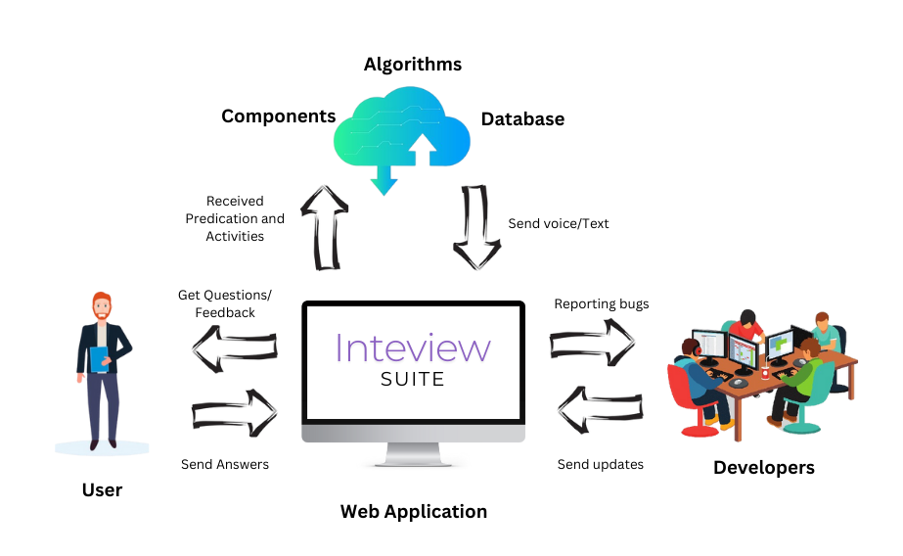

Figure : Rich Picture Diagram

**1.8 Resource requirements**

**1.8.1 Hardware requirements**

|  |
| --- |
| **Server:**   * **RAM** : Minimum 8 GB RAM for Smooth application performance. * **CPU** : Multi-Core processor for handling current requests. * **Storage** : SSD Storage for faster data retrieval. |

|  |
| --- |
| **User:**   * **Microphone** : To provide oral responses. * **Webcam** : Essential for video-based interaction. * **Headphones** : Help users hear questions clearly. * **Desktop or Laptop** : Users will need a capable device to engage with software. * **Stable Internet Connection** : Real time processing and feedback during the interview. |

Table : Hardware requirements

**1.8.2 Software requirements**

|  |
| --- |
| **Backend Development :**   * **Language :** python * **Framework :** Flask * **Database :** MySQL |
| **Frontend Development:**   * **JavaScript Framework :** React.js * **Styling :** CSS * **Designing Tool :** Figma and Adobe Illustrator**.** |
| **Development Tools:**   * **Backend:** pycharm * **Front-end :** Intellij idea |
| **Version Control System:**   * **Git :** version control system for tracking changes. * **Github :** As a distributing server. |
| **Collaboration and Project Management Tools :**   * **Collaboration platform :** Microsoft team/Google meet * **Project Management :** Clickup |
| **Real-Time Communication:**   * **WebSocket :** Flask-SocketIO |

|  |  |  |  |  |
| --- | --- | --- | --- | --- |
| **Continuous Integration/Continuous Deployment (CI/CD)**   |  |  | | --- | --- | | **Github Actions :** CI/CD tools for automating development pipeline. |  | |  |  | |
| **AI Models and Libraries**   * **Speech-to-Text Processing :** OpenAI Whisper * **Facial Expression Analysis :** OpenCV with Deep Learning Models * **Voice Analysis for Emotional Tone :** Librosa (Python Library) * **Pose Estimation APIs :** OpenPose |

Table : Software requirements

**1.8.3 Data requirements (optional)**

*If you are doing a data science project, you may require appropriate datasets to work on the tasks. You need to identify them and include those requirements here.*

## **1.9 Business model canvas**

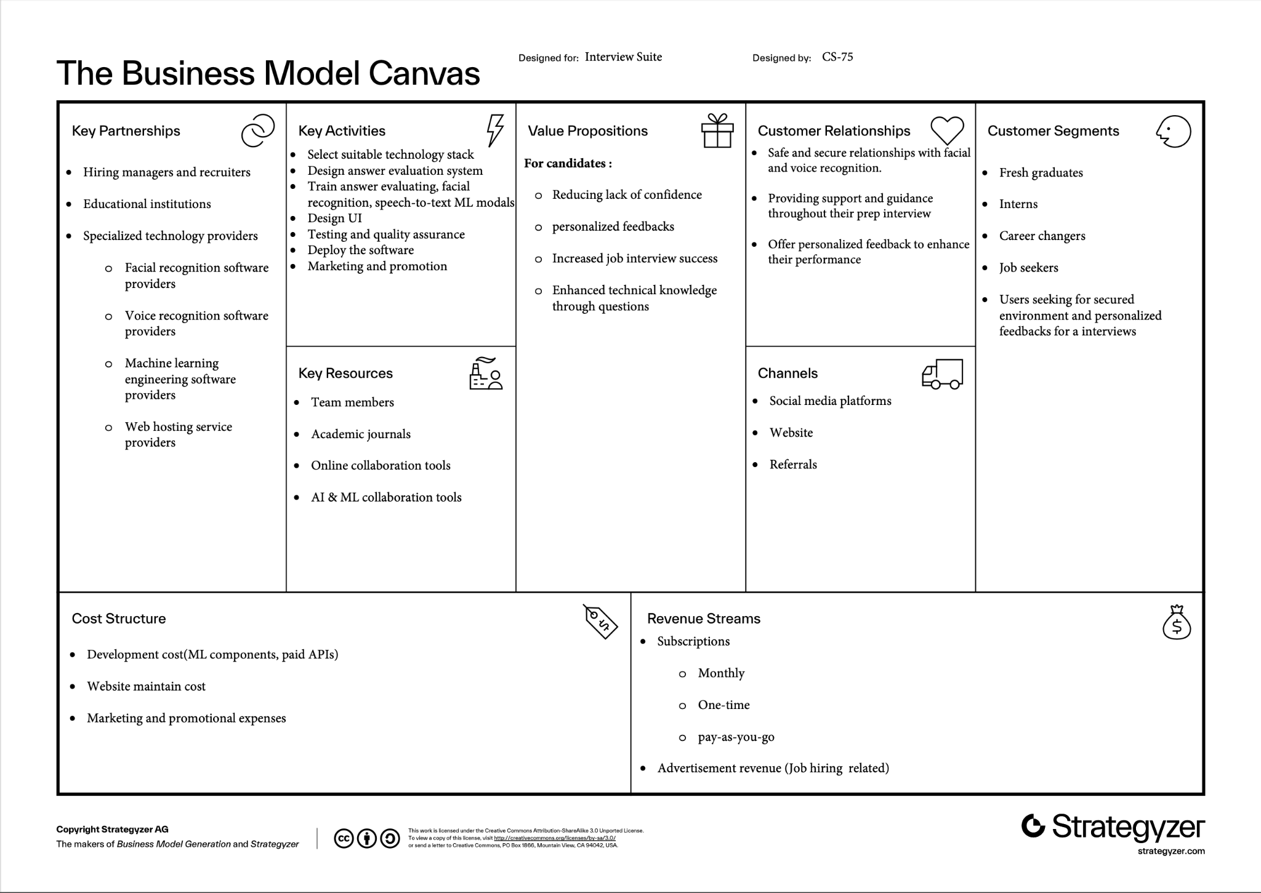

Figure : Business model canvas

## **1.10 Chapter Summary**

A summary of this chapter including its main objectives and conclusions. It contains the gist of the actual ideas that were discussed and also points to the importance of building the AI powered interview preparation platform. With such a broad range of technologies, we wanted to integrate all of them into one platform. AI driven voice analysis, body language assessment and dynamic question generation for a complete interview preparation experience during the recruitment process. The chapter explores the challenges faced by job seekers, the proposed salutations and the key technological components that make the salutation feasible and the Summary summarized the chapter. It gives a quick but complete overview of the chapter essence for readers to understand the chapter’s purpose and outcome.

# **Chapter 2: Existing work**

## **2.1 Chapter Introduction**

In this chapter, the state-of-the-art in interview preparation solutions is reviewed to determine the needs of candidates. The discussion also embraces the comparison of the solutions offered by existing competitors and incorporates the feature comparison along with the benchmarking reviews and technologies, approaches and algorithms used. Also with regards to the transition to tools and implementation, the chapter also identifies techniques and tool that can be used in the proposed interview suite platform.

## **2.2 Existing Work**

### **2.2.1 HireVue**

#### **2.2.1.1 Competitor analysis**

HireVue is an AI powered hiring and interviewing platform. HireVue helps companies to streamline the interview process by using video interviews, AI based assessments and use of tools that can analyze candidates.

#### **2.2.1.2 Key features**

**AI powered video interviews with behavioral and skill assessment**

Candidates face few questions and based on how they answer, responses are being analyzed through AI. hirevue assess both content delivery in the responses and analyze speech patterns, facial expressions.

**Candidate convenience and engagement**

Candidates allowed to face interviews on preferable times, offering flexibility on demand interviews.

The proposed Interview suite stands out better than hirevue because of real time feedback and generative questions. As a service provider hirevue gives a good set of features for hiring companies and recruiters but doesn't give in depth feedback on candidates.

#### **2.2.1.3 technology/ algorithms / approach:**

AI and machine learning - hirevue use natural language processing(NLP ) algorithms to analyze spoken responses. AI assesses both context and contents of the given responses. Deep learning models assesses facial expressions, body language and tone of voice.

### **2.2.2 BarRaiser**

BarRaiser is a modern interviewing platform powered by AI that seeks to enhance the hiring process for organizations.Baraiser provides Interview as a Service (IaaS) which involves managing technical interviews and evaluating candidates in order to cut the time hiring managers spend on unqualified applicants. The company is equipped with features such as scheduling interviews/real time interviews/feedback and detailed score carding. In addition to this it also incorporates bias free ai based evaluations.

#### **2.2.2.1 Key features**

**AI for Interview Assessment:**

While all of them have positive aspects, companies such as BarRaiser use AI to provide you feedback in real-time during your interviews. Provides interviewers structural consistency by suggesting relevant questions & notes you on moments covering key areas, making it easier to evaluate applicants with structure and neutrality.

**Scoring and Skill Matching using Machine Learning:**

For instance, machine-learning algorithms map answers from interviews or match skills of candidates to job-specific criteria. The scoring model automatically identifies high-potential candidates on the basis of their responses by estimating the degree to which a candidate will fit into your organizational culture.

**Instant AI Summaries and Click to Highlight:**

Smart summaries that highlight the critical moments of your interview are also part of BarRaiser’s technology. It enables hiring managers to efficiently and accurately evaluate the thought process of candidates by skimmed review questions part.

**Bias Reduction and Diversity Consideration:**

BarRaiser AI Models are designed to work in a way where the unconscious bias is reduced hence the sole focus remains on competencies and objective performance metrics. With this, companies are able to evaluate the skill set of candidates from different backgrounds accurately.

#### **2.2.2.2 technology/approach/ algorithm review**

algorithms to increase the effectiveness of the selection process and manager hiring decisions. Its approach is based on AI-enforced tools implemented within a single interview intelligence framework. This covers structured interviews which due to their structure, establish standard measures and reduce bias in the rating process. AI tools produce insights which can be used for providing recommendations for the interviewer, maximizing the efficiency of interviews, and improving the quality of the specific interview.

The key attributes include proposed questions based on job specifications, instant feedback as well as record interview for future use. This is in addition to regular assessments carried out through assessment games and behavioral analysis meant to cover all aspects of the candidate’s skills as used by BarRaiser. It also extends support to introduce interviewer panels from different countries of the world to minimize regional or cultural biases. Further, research informs the interviewers regarding ways to improve the methods used in interviewing and how to achieve a fair system of staffing.

Together, these technologies make it possible for BarRaiser to provide accurate, bias-free, and standardized recruitment solutions that can help organizations hire the right talents without spending a lot of time and money on the process.

### **2.2.3 Big interview**

Big interview offers interview preparation services, users can manually select from a list of questions that are either industry specific or industry questions, record their answers and get immediate feedback in addition to insights for improvement. Platform aims to simulate one-on-one sessions with a career coach.

#### **2.2.3.1 Key features**

**Learning modules with video lessons:**

Brief lessons covering as such as interview preparation, behavior in interviews, facing difficult questions.

**Mock interview simulator :**

users can record practice answers for the questions and review thieir performance, build communication and confidence.

**Answer builder:**

Helps users develop well structured answers to common and tricky interview questions.

#### **2.2.3.2 technology/approach/ algorithm review :**

biginterview primarily relies on web-based technologies for question presentation,answer recording,and feedback delivery.The core approach focuses on user recorded responses and uses prepared sets of questions.

#### **2.2.3.3 Testing and Evaluation Metrics**

Big Interview assesses user performance based on,

* Facial Expression Accuracy:evaluates the system’s ability to identify facial expressions accurately.
* Verbal Phrase Evaluation : evaluates the suitability and clarity of verbal responses.
* Confidence Level Assessment : evaluates the simulator’s ability to identify and provide feedback on the candidate’s confidence level.

**Comparison between the platforms**

|  |  |  |  |  |
| --- | --- | --- | --- | --- |
|  | Interview suite | HireVue | BarRaiser | Big interview |
| Facial expression recognition | Yes | Yes | No | No |
| Voice recognition | Yes | Yes | Yes | Yes |
| Personalized feedback | Yes | Yes | Yes | Yes |
| Practice questions customized on user preference | Yes | Yes | Yes | Yes, Question library |
| Dynamic question generation | Yes | Yes | Yes | No |

Table : Comparison between the platforms

**2.3 Tools and Implementation plan**

In this section detail the tools and techniques, requirements for implementing this AI powered Job Interview Platform. For this implementation we have to choose each element very carefully to ensure strong functionality. There are several advanced features that help users enhance their approach. People who are looking for jobs (interview candidate) can have a professional interview environment at the end with real time feedback for each section, for companies who hire people can filter candidates based on their requirement by analyzing the candidate feedback and their scoreboard.To obtain these kinds of advanced features we have to implement an implementation strategy to effectively manage each development stage.

**2.3.1 Tools**

If we want to make this implementation successful we need the help of both hardware and software components. These hardware requirements are divided into two main parts. Server Requirement for the backend infrastructure and User Requirements for the individual accessing the platform.

**2.3.1.1 Hardware Requirements**

**Server Requirements**

Our server configuration is made to provide quick, responsive service when high periods like when multiple users access the system at once. These server requirements ensure the stability of this platform, speed data processing and smoothly handle several requests at the same time.

* RAM

Minimum Requirement: 8 GB

For the system to manage the real time data processing task a minimum of 8 GB RAM is necessary. The system can load, run and respond to multiple tasks simultaneously at once without lag or crashing the system. It keeps the system responsive while handling multiple users interacting.

* CPU

Requirement: Multi core processor

To manage various tasks like handling multiple user sessions at once a server should have a multi core processor. With the support of a multi-core processor the system can handle incoming requests from various users, process their request and data, provide feedback based on their response without any interruption.

* Storage

Requirement: SSD

SSD storage is substantially faster than conventional hard drives(HDD). SSD enables quick data retrieval and users receive fast responses when interacting with the platform.A smooth user experience is supported by this SSD also help in manage large dataset such as audio, AI processing data in shorter access time.

**User Requirements**

Users must be able to use specific hardware on their end to fully utilize the platform's flawless interview experience. These components help to make sure high quality audio, video and interactive features are required for more accurate immediate feedback.

* Microphone

An important component of the interview simulation is the ability for users to answer questions verbally. A microphone lets users respond to questions with good accuracy. Based on this verbal accuracy it will decide all of the other crucial points a candidate must have. Basically this verbal accuracy affects everything else. To ensure that the user's voice is clear for accurate analysis we highly recommend an external microphone.

* Webcam

For the analysis of the user's body language and posture, facial expressions and other non verbal communication the system must obtain the user's clear visual clues. A good high quality webcam provides clear visuals to help to do accurate AI analysis. It allows the system to capture needed information that provides meaningful feedback.

* Headphones

A good headphone gives the opportunity to the user to improve audio experience to help clearly hear interview questions.

* Desktop or Laptop

A powerful device paving the way for users to do interview processes without any interrupt. It will handle video and audio processes without lag. The system makes use of real time data interchange, AI analysis and processing and code base question prompt provided by the system to do via system provided IDE environment will be ensured by a device with a decent processing power and enough memory will make this procedure smooth.

* Stable Internet Connection

A stable internet connection is necessary for on real time data transfer and processing, instant feedback. To maintain accuracy the connection should support video and audio streaming without buffering, to make sure users receive immediate feedback at the end of the interview session should have a good strong stable internet connection.

**2.3.1.2 Software Requirement**

To build an AI powered Job Interview platform with advanced features we have to carefully choose a set of software technology and tools. The platform should be able to manage various kinds of additional advanced features like real time data processing, AI based analysis and provide feedback for user response answers. The software stack needs carefully selected both frontend and backend development and the tools we will use for collaboration and deployment.

**Backend Development**

There are various kinds of backend development programming languages. Node JS, Python, Java, GO are some of the powerful programming languages that can implement enterprise level software with AI powered. To get successful output we need to select the most suitable framework and Database for each programming language.

* Programming Language: Python

Since this software is handling various kinds of AI powered features Python is the most suitable programming language that can implement backend parts interacting with ML modules. Python is a strong programming language and is well known for its simplicity, flexibility and it has large libraries that help to implement large scale softwares. It is the most preferred language for AI, Machine learning(ML) and Natural Language Processing(NLP). There is a lack of powerful frameworks to help Python build large scale softwares. It has a large developer community and is a well supported language to maintain and scale the platform over time.

* Framework: Flask

We need frameworks that help developers build applications faster and better with more Consistency, time saving, readability and with security features. There are multiple frameworks for Python, Flask, Django, CherryPy, Grok, Plons project, TurboGears are some of them. Flask is lightweight and well suited for small sized to large size applications specially those with microservices based architectures. It is easy to use, scale and flexible. Flask is perfect option for real time applications where allows rapid development of web services and APIs, for feature like process user data in real time and give feedback based on user response, scoreboard creation and performance analysis the best option is going with Flask python framework which is crucial for our AI powered features.

* Database: MySQL

This platform required a reliable, open source relational database management system(RDBMS) to store structured data. Because of highly scalable, secure and support complex queries with ease MySQL is blended with our platform. It's easy to manage user data(job seekers and employers), interview results. Feedback and valuable data such as user responses, scoreboard and performance metrics using MySQL as our database. MySQL's structured storage will ensure that data integrity is maintained, and fast quarry capability will provide real time performance analysis and quick retrieval of data.

**Frontend Development**

After implementing the backend part then we have to move to the other most valuable part, the Frontend part responsible for creating user -friendly interfaces for our platform. The main part of this frontend section is to build components that interact with users. For success in this part there should be cross browser compatibility, optimize page load times, integrating with backed systems ect. To get successful output we need to select the most suitable frameworks and libraries for this frontend development.

* Java Script Framework: React.js

To achieve main features in a frontend development like responsive user interfaces, building dynamic and fast, Search Engine Optimization(SEO), navigation ect. React js is a powerful and popular javascript library. In our platform, the frontend will be extremely interactive, allowing users to engage with AI powered features like given feedback based on user response without page loading, with React we can do those functions without any issues. React is component based architecture because of that we can easily manage the platform's UI elements and make it ideal for handling complex user interaction in real time. It is also highly performant, guaranteeing perfect user experience even as the platform scales up.

* Styling: CSS

To give well styled user friendly and attractive interfaces we should use CSS as the styling fundamental for the frontend of the platform. CSS has several styling frameworks that help to style and give responsive features to websites. By using this CSS and frameworks like Bootstrap or Tailwind css we can manage our platform's responsive design to ensure that the platform works well across different devices, colors and layouts.

* Designing Tools: Figma and Adobe Illustrator

Before we develop the frontend at once first we need to create user interface wireframes,

Prototypes and high fidelity design. It is perfect for a collaborate in real time enables

designers to work together in real time.

**Development Tools**

* Backend Development: PyCharm

A good IDE specially designed for the Python programming language is known as PyCharm. It has great facilities for debugging, for the identification of errors within the code as well as for code hints. The reason why PyCharm is the best IDE for developing backend using python on this platform is because of the following features: virtual environment, flask support, and version control. It ensures that the aspect of the application that will run hidden from the end user is clean and efficient, it also helps to speed up the development process.

* Frontend Development: Intellij IDEA

Intellij IDEA is a highly functional IDE for building modern web applications. Supports React.js JavaScript and other web development technologies. The features of code editing and debugging of Intellij IDEA will allow the developers to create and manage the frontend of the platform efficiently. It is the most suitable for the complex UI that is needed for the interview platform due to the great features it has in the management of large applications.

**Version Control System**

* Git

Git is a distributed version control system that developers in modern programming apply to manage different versions of a project and the record of the source code. It allows several developers to work on different platform components at the same time and none of them lose their changes. Git ensures that every alteration done in any project can be traced and if necessary undone to a specific previous stable state.

* GitHub

GitHub is an online hosting service which utilizes the Git version control system for SCM. It is the location where the whole team will be keeping, organizing, and editing the code. GitHu also has the branch, pull request, and version control, which are very important for a team. It also supports easy development by the integration with CI/CD tools as explained below and also supports code reviews to improve the quality of the project.

**Collaboration and Project Management Tools**

* Collaboration Platform: Microsoft Teams or Google Meet

With the help of these platforms, team members will be able to chat in real time, and conduct video conferences. Since the team is distributed or physically located in different areas, Google Meet or Microsoft Teams will ensure effective brainstorming, meeting and discussions while ensuring perfect teamwork during the development phase.

* Project Management: Clickup

Clickup is a complete project management application that offers task assignment, progress tracking, and deadline tracking as well. It will help the team in making assignments to some members of the teams, overseeing numerous developmental activities and ensuring that the project is completed on time. The features of visual task management and collaboration tools available in Clickup will also enhance communication between different positions in the team.

**Real time communication**

* WebSocket: Flask-SocketIO

Real time two way communication of the client and server is only possible with WebSocket technology. For real time communication during interviews, Flask- SocketIO will be employed in the application. This includes responding with typed, spoken and even streamed video feedback in real time, as well as immediate feedback from the AI. The type of communication that Flask-SocketIO enables includes bi-directtional communication whereby messages can be sent and received frequently between the client and the server without page reload enhancing the User Interface Quality.

**Continuous Integration/Continuous Deployment(CI/CD)**

* GitHub Actions

Github actions is a CI/CD tool that can be used to test, build and deploy the project on its own. It works well with GitHub and allows for creating own workflows. In this project GitHub actions will be used to create the pipeline for testing, building and deploying the code to the production server. GitHub actions like a CI/CD pipeline improves development cycles, maintain the quality of codes and hence lessen the exposure of the production phase.

**2.3.2 Implementation plan**

The evaluation of the implementation process of the AI powered interview platform, in this system develop and bring to market is written in the implementation plan. The thought process is to ensure that every component is carried out in a systematic manner to allow for categorized optimization so that the total of the end product will also be completely reliable and qualitatively impressive. How each stage is useful in improving the performance, operation and functionality of the system is outlined in the Implementation Plan. The planning and organization this platform achieves in this way remains optimistic that all the parts of the finished product would be designed, manufactured and put to test with equal levels of attention and professionalism hand would make the final product to be flawless and reliable. It reveals that each stage of implementation carries out a specific role regarding the overall performance, usefulness and functional features of the platform.

#### **Implementation Steps:**

#### **Requirements Gathering and Analysis**

This is the first and one of the most important activities in the implementation plan. It entails determining and analyzing what the platform has to do for its users and stakeholders. The requirements gathering and analysis phase forms the development framework of the project since it helps streamline the total of the project needs, functionality and objectives to match the team’s expectations.

* Identify Stakeholders

Identify the audience of the system to include both the direct and indirect consumers for a start this includes job seekers, technical reviewers and employers. Stakeholders are also those that consist of the project team and any other institution which is approving or sponsoring the project.

Purpose: Owners can be aware of their respective requirements and expectancies since identifying stakeholders is significant.

* Define Objectives

It is also important to define what the platform is designed to accomplish.

1. Simulate interviewer and provide feedback
2. Use AI to evaluate response accurately
3. Offer a user friendly experience

Purpose: Having objective lays down a framework in which the team operates

Since its goals, objectives and takes are well defined and measurable.

* Conduct Research

The research part is also necessary to explore what is already doing the market, individual technologies and user habits or lack of them respectively. Lurch about other solutions and their limitations.This lead to the creation of a platform that differentiates and delivers value propositions.

* Engage Users for feedback

Ask potential users such as job seekers and employers to complete questionnaires, fill in structure interviews or participate in focus groups. This includes gathering data about their weak points, expectations and must have features.

* Document Functional Requirements

Enumerate all the requirements that the platform has to provide and enable.

1. AI powered questionnaires and response analysis.
2. Real time feedback during interview sessions
3. Secure storage of user data and results

This is useful for developers to refer to in order to guarantee that the basic

features are integrated.

* Document Non Functional Requirements

Define attributes like,

1. Performance: It is designed to handle many users at the same time without any inflection in performance
2. Scalability: Be able to easily expand to future features if needed.
3. Security: Encrypt users data and use a secure method of entering the site.
4. Make sure the platform is easily understandable by the clients.

These requirements make sure that the platform runs efficiently and delivers more the bare minimum to the user

#### **System Design and Architecture Planning**

System design and architecture planning are crucial milestones in the road to developing a robust and scalable platform efficiently. This stage focuses on transforming the needs defected into an imagined scheme that guides the development team. It makes sure different components of the system function effectively and technically together, delivering the required user experience while meeting project objectives.

It helps in devising a skeleton for the overall architecture of the application by defining how the frontend, backend, database, and external services are supposed to interact with one another. This phase will also consider the scalability, performance, and maintainability of the system, knowing that it may need to grow in the future.

**System Design and Architecture Planning Steps**

* Define System Architecture

Choose the architecture type for the system. For this project, the client-server architecture is implemented with the use of the microservice approach in the back end.

This separation of concerns offers modular development, easy maintenance, and scalability. The client (Front-end) interacts with the back-end over REST APIs, and real-time communication is enabled by the use of WebSocket technology.

* Database Design

Design schema for MySQL Database. Key considerations are:

Database Schema entities relationship: Table for users, interviews, question sets, results, and feedback.

**Normalization**: Minimize redundancy to efficiently store and query data.

**Indexing:** Improve the speed of frequent queries related to fetching user results.

**Purpose**: A well-designed database ensures consistency and integrity of data. It also ensures that retrieval and manipulation operations are carried out with speed and accuracy.

* System Components

Split the system into smaller components as listed below,

**Frontend:** Handles the user interface interactions; its role is to show real-time updates.

**Back-end service:** The key responsibilities of the back-end services include AI-based question generation, answer analysis, and interaction with the database.

**Database:** This would store user information, interview responses, and results.

**Third-party integrations:** This could include tools such as Flask-SocketIO.

**Objective:** Modular building blocks will ensure that the system is easier to develop, test and maintain.

* Select Technology Stack

Choose tools and frameworks that will be used for each component,

**Frontend:** React JS with CSS will be used for the dynamic UI.

**Backend:** API development will be done using Flask, AI and NLP will be powered with Python.

**Database:** the database used for structured data storage will be MySQL.

**Real-time communication:** The interactive feature of live feedback will be introduced using Flask-SocketIO.

**Purpose:**A well-thought-out tech stack ensures compatibility, efficiency, and productivity for the developers.

* System integration Points

Specify how different components shall communicate and share data with one another. This would involve the following,

How different components may communicate and share data, including REST APIs for data exchange between the front and backend, database queries to fetch information, and WebSocket for real-time interactions during interviews.

Defining the integration points negates any chance of miscommunication between different components, hence guaranteeing smooth integration.

* Security Features

Specify how user data will be secured and how safe the interactions will be encryption of data at rest and in transit.

**Authentication:** Provide a secure authentication mechanism using OAuth or JWT tokens.

**Input Validation:** Validate user input to prevent malicious attacks like SQL injection.

This is so that security will help build trust with help to build trust with the users and project sensitive information.

* Scallion and performance Planning

This is necessary for planning the scaling of a system to hold more users without degraded performance, which would be possible by Load balancers to distribute traffic evenly. Following a modular architecture for ease is adding features. Optimization of database queries to perform faster.

The purpose is to make the system grow and perform efficiently under high load.

* Create System Diagram

This will show the systematic structure of the system by implementing visual displays, such as UML diagrams, flowcharts, or architecture blueprints. As an example,

**User case diagrams**: That represents the major components and their interactions.

**Data Flow Diagrams(DFD)**: That represents the flow of data through the system.

Purpose: These diagrams help developers and stakeholders to understand the system and identify the potential problems early.

#### **Frontend and Backend Development**

Frontend and backend development are the two most important aspects of any software system. The frontend is concerned with the graphical user interface of the application and makes the application user friendly. It enables users to communicate with the system friendly, to input information and to get the results from the system. The frontend would deal with the view which makes user inputs and displays necessary information whereas the backend deals with the operations performed on the data by a user and data stored in the database. They are well integrated to provide a functional and responsive system as the two parts of the whole.

In this project the clean separation of the frontend and the backend is more advantageous

in maintainability, scalability and user experience.

**Frontend Development**

The frontend is implemented with the help of React JS the rapid and flexible JavaScript

Framework. Styling is done using CSS for aesthetic designing tools such as Figma and

Adobe Illustrator for designing and creating friendly interfaces.

* Setting the Environment

1. Install Node.js and React.js
2. Connect utilizing components and reasoning methodologies for enhancing their availability and configurable rendering.

* Design the User Interface

For the application interface utilizing Figma and Adobe Illustrator in order to determine and implement the visual design in the application. Clarity is important to make the design look good and to be easy to navigate.

* Build React Components

Create modular and reusable components like,

1. Login/Register form
2. Question Pages
3. Result Dashboard

Since it is a components based system, it proves easier to update and maintain.

* Implement Dynamic Interactions

Use React’ s state management and hooks to make the interface responsive and

Improves user experience by allowing real time interaction.

1. Show the candidates the feedback in real time during the interview.
2. Change question pages as the users go through them

* Connect to Backend APIs

Use Axios or Fetch API to send user inputs to the backend and retrieve processed results.

User types answers → Frontend transmits data to backend → Backend receives and returns feedback.

It makes it easy to have communication between the frontend and the backend.

* Testing and Debugging

**Backend Development**

For the backend Python and Flask framework is used as the implementation language due to its minimal essence and microservices architecture. For instance the backend handles the user data, conducts or executes the AI models as well as communication with the MySQL database to store and even retrieve the data.

* SettingUp the Backend Environment

1. Install Python and connect with the Flask framework.
2. Setting up environment for libraries for AI, NLP and database interaction

* Create RESTful APIs

Build APIs for handle,

1. User Authentication
2. Interview Questions
3. Results and Feedbacks

These APIs serve as the bridge between the frontend and backend.

* Integration AI and NLP Models

Use python libraries to analyze user responses, Generate scores and feedback. Enhances the system's ability to access answers correctly and makes the system intelligent.

* Database Interaction

Connect backend with MySQL database and perform operations like,

1. Store user details and answers
2. Retrieving question for the interview
3. Saving feedback and results

Recognize for facilitation for effective data management and retrieval.

* Implementing Real Time Communication

Use Flask SocketIO to enable live interaction. Give feedback during the interview as soon as possible, show it steps by steps while they answer the questions. Improve the interaction between the user by making the system familiar to him.

* Handling Security

Implement security measures such as,

1. Use hashing algorithm to encrypt user password in the system
2. Securing API calls by verifying the access requests
3. The one that controls access and those that are safe such as the JWT(Jason Web Token)

* Testing and Debugging

When the frontend and backend are developed they are connected through REST APIs.

The frontend transmic calls to the backend and manages responses as well as modifies the

application interface. For Real time features, bidirectional communication is achieving

through webSocket.

#### **Integration of AI and ML Models**

AI and ML models are also used in this project and are considered to be an essential component of the project. These models help the system to assess the user's response, provide feedback, and even make intelligent decisions. With the help of AI and ML, the application can identify enormously multilayered inputs provided by the user either in the form of written statements or video feedback and consequently provide timely and meaningful results.

It is a process of data pre-processing, model retraining and then putting the models through an integration pipeline for optimization and real-time runtime. Please find below a clear categorization of the way AI and ML is implemented in the system.

* Problem Definition and Model Selection

This approach emphasizes the importance of avoiding unclear objectives by clearly defining the specific functions that AI andML models are expected to perform.

Employ BERT, Llama 3.2 and GPT-styled NLP models for language compression. Using structured data scoring models such as classification algorithms is one of the model selection approaches.Guarantee that the model which has been chosen corresponds to the goals of the system as well as perform the necessary actions effectively.

* Data Collection and Preparation

Gather a dataset to train, fine-tune or evaluate the models. This could include a database of frequently asked interview questions and solutions, pre-label datasets for training of sentiment analysis, and scoring models.

Data cleaning: Remove duplicate data, preprocess text data in a way of removing words that have no relevance in the context data, remove whitespaces of converted voice to text responses, reduction of words to their base form or root words.

* Model training and Testing

Train the model using labeled datasets and appropriate algorithms.

1. NLP Models: Sharpen applying for instance through Hugging Face Transformers or spaCy.
2. Scoring models: Supervised methods should be applied in order to assign predetermined scores to answers.
3. Speech to Text Processing: OpenAIWhisper
4. Voice Analysis for Emotional Tone: Librosa
5. Facial Expression Analysis: OpenCV with Deep Learning Models
6. AI libraries and tools: Dlib, OpenCV

Use the different models to predict on unseen datasets to determine the accuracy,

Precision, recall.

Improve overfitted models of current available models of pretrained models for better

specific domains.

* Model Deployment

Implement the models into the backend using some frameworks such as Flask-RESTful or FastAPI. Makes it possible to deploy the models at scale for production while also being easy to update.

* Real-Time Integration

Integrate the AI/ML models in the application flow so that it acts as a parallel process on the go.

1. Text based Responses

User submits an answer → Backend processes it through NLP model → Returns feedback.

1. Video based Responses

Convert frames of a video through computer vision models for evaluation of facial emotion as well as gestures.

Manages the models applied,current and changed with regard to emerging requirements.

#### **Database Setup and Configuration**

It is therefore important to have well-structured and optimized database to be able to manage data and store data in any application, In this project, the work that is performed on the database environment and configuration mainly aims at establishing a strong and stable ground to manage the user information and configuration mainly aims at establishing a strong and stable ground to manage the user information together with the responses, feedback provided by the AI and the logs of the application. MySQL is chosen as the database management system as it is reliable, scalable and easily integrates with the FLASK based backend we have developed. This research aims at providing a step by step description of the process of database creation and setting up followed by database tuning.

**Steps for Database Setup and Configuration**

1. **Database Selection:**
   1. MySQL is an RDMS and it was selected for several reasons.
      1. Tables for handling structured data.
      2. Help for efficient querying using SQL.
      3. The ability to work with small and large datasets

Flask and MySQL are compatible and MySQL has a large community following, which is perfect for our system.

Purpose: Stresses the possibility of a stable and a proper architecture systematically to store and retrieve data and information.

1. **Database Design:**
   1. User Table: Saves user details such as their names, email and the login details they provide.
   2. Question Table: It includes predefined and AI created Interview questions.
   3. Response Table: Records users’ answers to questions, associated with the User and Question tables.
   4. Feedback Table: Stores the scores and other information created by AI for the user’s response.
   5. Log Table: Collect application’s occurred events for the purpose of debugging and analytics. References ( for example foreign keys) are built to create connections between databases and prevent duplication.
2. **Database Setup:**
   1. However,MySQL Server needs to be installed using the selected platform; either local or cloud.
      1. Create the project-specific database:
         1. Example: CREATE DATABASE interview_ai;
      2. Identify and run create sql query to create tables and their relationships.
      3. Tools Used:
         1. MySQL Workbench: For the creation of schema and the running of SQL scripts.
         2. Command Line Interface: In case of direct operations in the database.

Purpose: These are limited libraries defined in the application, but these create the

database structure needed for the application.

1. **Backend Integration:**
   1. Another thing is to link the Flash backend with the MySQL DB using the Flask-SQLAlchemy, the object Object-Relational Mapping (ORM) tool. ORM helps make interactions easier and involve working with a database through Python objects instead of SQL.
2. **Data Initialization**

Populate the database with initial dataset:

* Predefined Questions.
* Example user profiles for testing.

This data can be loaded in the database by use of SQL scripts or own responsibility mapping migrations. Purpose: Gets the database ready for first time use and testing by the application users.

1. **Security and Access Control**

**Implement measures to secure the database:**

* **Authentication and Authorization:**

Limit database usage by randomly allowing only certain users and or applications.

* **Data Encryption:**

For matters touching on passwords, ensure that they are encrypted by hashing as these algorithms include bcrypt.

* **Backup and Recovery:**

Set up time table to make database backup in order to avoid loss of valuable information.It is recommended to perform tests of recovery procedures on a regular basis.

* **SQL Injection Prevention:**

This should be prepared using ORM based queries and prepared statements to reduce the risks associated with injections.

Purpose: Preserves user and system information from unauthorized access and possible violation.

1. **Testing and Monitoring**

For real time metrics of the database, phpMyAdmin or MySQL Enterprise Monitor can be used.

Purpose: Verifies that database is stable and is able to perform well under pressure.

Database setup and configuration are critical to the success of the application in question. In choosing MySQL, in designing the schema and incorporating it with the backend, we are able to guarantee that we are able to manage the data we need in a reliable, secure and scalable manner. It also ensures that the database continually meets the application performance demands as well as adapt to the users’ changing demands.

#### **Real-Time Communication Setup**

Another important aspect in this system is the possibility of real time communication which allows the user to interact with the platform. It provides the possibility of fast response and creating updates during the interview which will improve the users interaction and sensitivity. In this project use real time communication by using WebSocket technology with the help of Flask-SocketIO. The arrangement enables the server as well as the client to send messages back and forth and data transfer is as quick as a blank an eye without the need to ask for another request.

The following subsections provide a detailed description for how real time communication is achieving in our system.

**Steps for Real Time Communication Setup**

1. Choosing the Technology

Essentially for real time communication, WebSocket is used, it is a protocol that maintains event loops between the browser and the server. WebSocket is different from the normal HTTP in that it supports real time bi-directional communication.

Flask-SocketIO is selected as the integration library for Flask because it makes WebSocket management easier and offers characteristics for real time interaction.

1. Installing Required Dependencies

To enable and get features of WebSocket in Flask bellow dependencies should install

**pip install flask-socketio eventlet**

Eventlet or gravent is used for an asynchronous to deal with concurrent WebSocket

Connection efficiently.

1. Setting Up Flask-SocketIO

The server side configuration process includes running SocketIO for Flask applications.

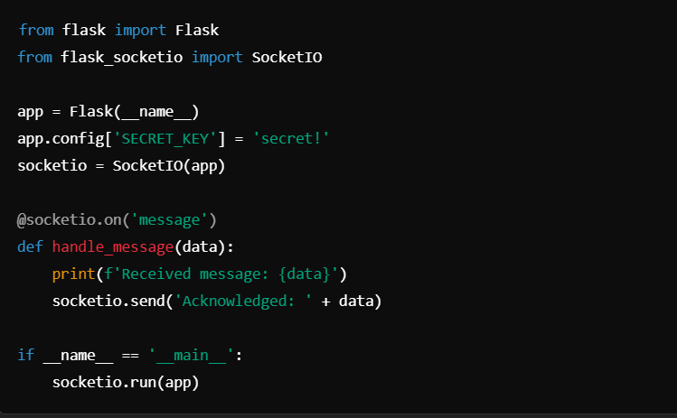

Figure :Setting Up Flask-SocketIO

handle_message : This function waits for messages and returns responses to the client immediately.

1. Client Side Integration

In frontend this WebSocket connection is handle via JavaScript

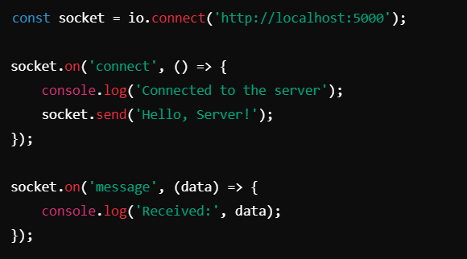

Figure :Client Side Integration

It makes it possible to send information to the server and receive an immediate response like AI generates prompts to the question or the update score.

1. Real Time Feedback Mechanism

During the interview sessions,

* The user's response, either voice, text or video is transmitted to the server through WebSocket.
* It takes the response from the client, gets assistance from AI models for processing the response and then generates feedback in the form f scores or tips and dispatches them to the client in real time
* For instance a user may notice that candidates score changes as soon as their answers for questions.

1. Handling Concurrent Users

With SocketIO the system is able to handle multiple user sessions at the same time.

* To avoid data overlap each user is provided with a different session ID.
* The Server employs the asynchronous event handling mechanism to enable it to run efficiently when handling large amounts of data.

The bellow testing tools will be used for various type of testing

* Unit Testing and API Testing: PyTest and PyTest-Flask
* Integration and Load Testing: Locust
* UI Testing: Selenium or Cypress
* Mocking and Code Coverage: unittest.mock or coverage.py

1. Error handling and Reconnection
2. Security Measures
3. Testing and Debugging

The real time communication setup constitutes the foundation of the interview platform that we have designed to be highly interactive. Using WebSocket and Flask-SocketIO provides real time and immediate communication between the user and the system. This makes the experience interactive, reactive and effective which is the aim of the project to develop an AI interview assistant.

#### **Testing and Quality Assurance**

Testing and quality assurance are important in the delivery of a reliable and user-friendly product. This phase will ensure that the system is fully functional to meet both performance and security requirements while providing an end-user experience free of glitches. The structured testing approach enables us to find potential issues and help to fix them before actual deployment on the platform working smoothly across different scenarios.

Below is a detailed explanation of the steps in testing and quality assurance for our project.

Steps for Testing and Quality Assurance

1. Test planning

Before the actual testing takes place, a very broad test plan is drawn out as,

Objective of testing (Features to be tested, Environments, Devices, and Platforms)

Testing Types to be conducted: Example-functional testing, Performance, Security

Responsibilities and roles of team members involved in testing

Purpose: Ensures that the test, as a process goes well and is aligned with project objectives.

1. Unit Testing

Each module or component is separately tested to verify that it works in isolation. As example,

Backend: The testing of APIs to return the data as expected and handle the edge cases.

Frontend: Individual React components to be rendered correctly and react to user inputs

Purpose: To enable issues to be detected quite early in the development phase and thus save time and effort that may be required later on.

1. Integration Testing

Test the interaction that happens between different modules. For example, the interaction of the front end with the backend APIs, real-time communication via webSockets, integration of AI/ML models with backend logic. API responses are tested using tools like Postman; mock data is created and used to simulate real interactions. To ensure that all these components interact smoothly and seamlessly.

1. Functional Testing

The validation process to be followed for features across the platform meeting requirements and working as expected would include,

Stimulating interviews and their respective scoring. Real-time feedback at every instance of interaction. User registration, login, fetching user information. The scenarios are tested for normal and edge cases in order to ensure reliability. The objective of this is to ensure the correctness of the system’s behavior concerning various user interactions.

1. Performance Testing

This tests the responsiveness and stability of the system under load.

Load Testing: it simulates multiple users using the platform simultaneously for testing the purpose of server capacity.

Stress Testing: The objective of this test is to understand how the system behaves when pushed to the limit.

One would use traffic-simulation tools like UXSim to generate traffic and perform measurements on performance metrics. This ensures the responsiveness and efficiency of the system during extreme loads.

1. Security Testing

Securing the platform against potential vulnerabilities

* user input validation against SQL injections
* Authentication and authorization mechanisms are tested for security of users’ data

1. User Acceptance Testing

The system is exposed to a natural environment for testing by the end users or stakeholders to ensure that the system meets expectations.

Feedback on the user experience, the usability of the system, and overall satisfaction is collected.

Identified issues are given due attention before final deployment. To ensure alignment of the system with the needs and expectations of users.

1. Regressing Testing

Regression testing is performed after an update or bug fix to ensure that new changes have not caused problems or affected existing functionality. Some UI-automated testing tools, such as Selenium, are utilized to automate this process. We will be able to recognize the purpose of this as system integrity is maintained through iterative development.

1. Automated Testing

Picked tests that are essential to efficiency and consistency are automated using the following tools, Pytest for backend unit testing, Cypress for front end-to-end testing, Test to be automated are those that are repetitive and cumbersome, such as login validation and data processing. This will save time and reduce inconsistency in testing between builds.

1. Documentation and Reporting

Extensive test reports are prepared after each testing phase, documenting the following,

* Test case executed
* Bugs detected and fixed
* Performance metrics and overall system health

Reports are shared amongst the team to ensure transparency, facilitate improvements in the progress and inform about system quality.

This is very important for ensuring that a reliable and robust platform is delivered. With a mix of manual and automated testing techniques, we ensure the system functions as required under all scenarios and provides a secure and friendly environment for the user, meeting project requirements. This extensive approach is meant to ensure the platform is ready to be deployed and thereafter have long-term success.

#### **Deployment and Initial Testing**

The deployment and initial testing occurs in a production or staging environment, which is different from the development environment as is seen from the above description of the system.It ensure that by the time the platform is deployed through for the end-user usage,the platform is already up and ready to go to meet all the needs and requirements.The first testing proves that the system runs successfully in its live environment, but deployment enters setting servers,application elements and databases.

The following subsections describe the process of deployment and initial testing.

Here are the steps for deployment and initial testing.

1. Environment setup

Install the necessary kit and gears in the hosting plane(these may include AWS,Azure or google cloud and others.)The initial establishment of the suitable operating system also entails legal implications.

Installations: MySQl,Flask,React,Python etc..

Apply firewalls,HTTPS and the proper access to the kind of environment you should protect.In the testing phase and the final operational phase, you want to implement production and staging environments.

1. Application Deployment

Install the relevant frontend and backend components:

Backend: Deploy Flask on the server, incorporate the AI/ML models and connect websocket on the real time chat.

Connect MySql database to the server side.

Frontend: Deploy the react application to the Netlify,Vercel or the same server that hosts the backend sections of the project.Configure the frontend to communicate with WebSocket and further APIs of the backend.

For spreading the changes and automating deployment practices conduct CI/CD pipelines-GitHub Actions.

1. Database Configuration

Those first datasets will then be migrated/seeded in to the mysql database.Migration involves creating of tables with information about user,interviews conduct and logs.

Check that the relations between tables are operating adequately.

1. Initial Testing

Conduct Initial testing to verify the critical functionalities:

It involves activities of registration of users and subsequent login procedures.The interactions that occur between the frontend and backend application which include API and WebSocket request and response.Execution of such operations on database like data read and write or generally data manipulation.

This category includes AI/ML model responses,scoring and real time solutions.

1. Load and Performance Testing

To assess server performance i real-world scenarios,simulate several users at once:

Verify server load,its capability and response time taken by the server.Discover inefficiencies in model processing,communication within artificial intelligence devices and provision of dara.

To the end of this, applications such as Locust,Apache Bench and Jmeter are employed.

1. Error Monitoring and Logging

For the real time monitoring of the application use the Datadog,ElasticSearch or Logstash the real time environment.For more research and troubleshooting log implementation events such as server downloads,API breakdowns and fluctuations in the system performance.

1. Stakeholder Feedback and Validation

Release the system to your team members, mentors or other selected end users to get feedback on.Check for the project’s functional,design and usability specifications.Collect feedback as to where you can make changes or as to where you should add some additional functions.

1. Document of deployment process

Information on the environment settings.List of installed versions and dependencies all the manipulations required in order to deploy.The team must have access to this documentation for reference at the time of troubleshooting and for the future.They make future deployment more reliable and free from errors that would have been made otherwise.

#### **User Feedback and Iteration**

The user Feedback and iteration phase is the subsequent stages where feedback is received

From Actual users of the developed system, with the view on receiving feedback for areas to improve, fix and enhance/optimize the developed system for easy usability and functionality. This guarantees that the platform is developed progressively with respect to the actual practice and is closer to the expectations of the users.

Through the use of the feedback from the users the system is updated periodically to ensure that it is accurate, useful and easy to use.

**Steps for User Feedback and Iteration**

1. Collecting User Feedback

Collect user’s feedback via various ways:

* Google Forms survey or any online survey form such as Typeform.
* Feedback forms that are within the application to allow for feedback to be given immediately when using the application
* Using surveys to get more information as well as conducting user interviews or focus groups.
* Data analytics tools such as Google Analytics monitor users' interactions and identify the weak points.

Make available means where certain ideas pertinent to the functionality of the application

can be posted by the user of the application. The purpose of the collecting user’s

feedback determines which aspects are valuable to users and what difficulties they meet

and how the situation can be enhanced.

1. Categorize Feedback

Categorize feedback to be able to prioritize one over the other,

**Critical Issues:**  Very simple mistakes or errors that compromise essentials operations like unable to login, incorrect scoring.

**Feature Requesting:** For additional features or improvement suggestions.

**Usability Enhancements:** Improvement areas for design, navigation or ease of use.

**Positive Feedbacks:** Emphasis on the aspect of the platform that have o be maintained

The purpose of the categorizing feedback is to enable the team to prioritize the greatest changes and make the most efficient use of update planning time.

1. Analyzing Feedback

Collection and analysis of the survey feedback to look for trends and general user complaints. The purpose of analyzing feedback is to their own needs of users and the importance of changes that may appear on the site or in the application to assess the relevant and feasibility.

1. Planning and Prioritization

Need a roadmap to implement improvement based on user feedback.

* Organize issues by their significance to users and amount of effort to address them.
* Use agile methodologies like Scrum to manage feedback related tasks

The purpose of this step is adds to the glad things that these updates are conveyed

methodically and efficiently.

There are more steps for success this User Feedbacks and Iteration section and they

are,Introduce improvements of the identified issues, addictions and innovations according

to the arranged ranking, after some modification on the system it is relevant to conduct

tests to see whether it complies with the anticipated user demand, continuous Monitoring

and feedback loop and the final documentation of the iteration process.

The user feedback and iteration phase constitutes the key to the development of a

Platform that would meet users needs. The system is constantly developing in terms of

value, functionality and efficiency due to the consideration of the user feedback. This

interactive. Approach makes sure long term success for both users and stakeholders.

#### **Continuous Monitoring and Maintenance**

**2.4 Chapter Summary**

Thischapter presented the detailed plan of action for the project, beginning with the Requirement Gathering and Analysis phase to identify the users requirements and define goals. It described the system design and Architecture planning, which is the basis for a good, expandable system. Inhere also talked about the Frontend and Backend areas, in which the user interfaces and server side facility for the particular project are developed and incorporation of AI and Machine Learning models to improve and provide better feedback of that particular system.

These others are Database setup and configuration, Real time communication setup, Testing and Quality Assurance on the security and effectiveness of the stored data. Last but not the least, Development and initial testing was mentioned as critical to the product launch and User Feedback and Iteration to sustain. This approach guarantees the transition from development o a usable platform and is the best approach.

**Chapter 3: Methodology**

**3.1. Chapter Overview**

This chapter discusses in detail methodologies for designing and managing the AI-driven interview preparation and candidate assessment platform. In the design of such a system, because of its complexity, the methodologies chosen should ensure adaptability, user-oriented focus, and modularity necessary for incorporating various AI components, such as voice analysis, body language assessment, question generation, and dynamic feedback. The effective adoption of Agile development, OOAD, and Structured project management allows this project to take shape from user feedback, technological advancement, and change requirements.

Agile Development methodology specifies the approach that needs to be followed for this project, integrating an iterative and flexible approach. Agile methodology has opted, as it can easily be adapted, which quite fits the bill when it comes to AI-driven applications. The frequent requirement for testing, optimization, and enhancement makes Agile quite apt for this kind od platform. Features incorporated in this AI-based analysis, dynamic question generation, and automated feedback will no doubt be benefited by the iteration cycles or “sprints” of Agile. Every sprint will focus on developing certain features, thus enabling the team operating on an iterative cycle to test, validate and, and refine each component incrementally. It also focuses on Agile’s emphasis on continuous improvement to iteratively tune machine learning models for real-world adaptation to new models or improvements in accuracy and efficiency.

The agile approach is also complementary to user-centric design principles, whereby regular feedback from both job seekers and employers is allowed in the development process. This feedback loop will ensure the usability and relevance of the platform, with adjustments based on real-world needs. Agility gives the required flexibility to the emergent requirement, which is very important in an AI project where new models, techniques, or algorithms might pop up during the development process. For example, suppose that there is the emergency of a much better model for body language analysis; Agile allows the team to shift in and integrate this improvement without the disrupting of the whole project. Agile allows risk mitigation by allowing incremental deliveries, thus reducing the risk of failure. It allows for the early identification and resolution of issues.

In this respect, the core design methodology is going to be Object-Oriented Analysis and Design. In such a way, the key requirements modularity, scalability, and reusability—are ensured by the platform. OOAD allows complex features to be modeled in a systematic way because every functionality voice analysis, body language analysis, question generation, and feedback evaluation is encapsulated into separate objects. This encapsulation makes the team treat each component as an independent unit of design, ensuring that each module is well tested and optimized before being combined into a larger system.

The design pattern that will help OOAD implement effectively is the Layered Architecture. The architecture divides a system into different layers, each having some kind of responsibility, be it interaction with the user, business logic, or data management. The layered approach works quite well with the principles of OOAD and allows the team to design a platform that's flexible and thus easy to maintain.

Combining OOAD with Layered Architecture gives a robust design framework for an AI-powered interview simulation platform. The way modularity, scalability, and ease of maintenance are guaranteed in this methodology is by dividing the system into manageable layers and encapsulating functionality into distinct objects. This approach does not only address the current requirements of the project but also lays the groundwork for seamless future expansions, enabling the integration of new features and AI modules without disrupting the core functionality of the system.

Project Management Methodology: The project management framework supports Agile Principles in development, while task tracking shall be performed via software clickUp. Collaboration tools:Google Meet , Microsoft Teams , Zoom. In the respect,the work of project management software would grant the team effective sprint planning , resource planning , and tracking of task completion. This systematic manner of projet management allows the team to keep on track with deliverables, maintain a balanced workload, and ensure time completion. Project management tools can also enable transparent communication and tracking of progress.Logos of weekly meetings serve to discuss issues that crop up,review progress,and discussion of feedback , hence keeping the project adaptable and responsive to changes.

The Work breakdown Structure of the team further explains how each and responsibility is shared among the team members and defines what each of them does. This further ensures the ability to maximize productivity in ensuring all different task are well handled,right from data gathering and model training to the integration and testing of the system. The WBS ensures that individual efforts are dovetailed with one another in such a manner that accountability at various levels can be ensured with a focused application of expertise on specific aspects of the project.

The Gantt chart further defines the timeline of the project, showing the mapping of each phase ,sprint , and milestone. The chart is necessary in planning and showing different stages of development sequentially right from the very early research and requirements gathering to the final testing and development.This Gantt Chart should be helpful to let the work be on schedule and also highlight any bottlenecks , which the team can then adjust according to need regarding scheduling and resource allocation.

Risk Management and Mitigation :This deals with the intrinsic vulnerabilities that come with an AI project , such as dataset availability issues,heavy workload because of other parallel academic commitments, and possible knowledge gaps. These are mitigated through proactive actions like building a repository of available datasets for easy access, documentation of resources for easy lookup, and collaboration with experts when needed. What Agile does is help mitigate those major project risks through the power of incremental development ,which allows the detection and resolution of issues in the early stages of every sprint.

The tool for collaboration and communication : These are very vital in maintaining team coordination and managing project documentation. Complementary to project management software , platforms such as Slack or Microsoft Teams will provide support for continues collaboration and communication. Meetings per week are documented so that all decisions and adjustments within these are documented for future reference, to enhance accountability and give a clear record of project evolution.

In other words, the current chapter establishes the methodologies that may potentially from the basis for the successful implementation of the AI-powered interview preparation and candidate evaluation platform.Agile imposes on an AI- based application flexibility, incremental improvement, and concentration on users, whereas OOAD provides modularity, scalability, and ease of maintenance .These approaches, combined with good project management,clear task distribution,risk management , and effective communication tools , enable the platform to be developed in structured yet flexible manner. The integrated approach followed in this chapter provides guidelines toward an intelligent , flexible, user-oriented platform that creates a very sound basis for delivering a solution that meets the demands of both job seekers and employers.

**3.3. Development Methodology**

The Agile Development Methodology has been selected for this project due to its flexibility, iteration, and adjustability in cases where requirements may change since the software will be an AI-driven application requiring continuous development and refinements. Since this platform may incorporate several elements, including AI-based analysis, dynamic question generation, and automated feedback, the Agile model is the best adapted to the handling of frequent testing, feedback and improvements.

**3.3.1. Reasons to Choose the Agile Methodology**

1. Iterative Development

This iterative approach by Agile lets the team break down the project into manageable sprints or cycles. In this context, each sprint will focus on building, testing, and refining specific features such as analysis of body language, voice analysis, and evaluation of answers. This way, each component will be well developed and tested before proceeding to the next one.

1. User-Centric Design

Agile puts much-needed emphasis on frequent user feedback, which is important to make the platform, such job seekers and employers, we should have gained insights from them, adapted features, and improved usability to make the platform useful for real-world needs.

1. Agility towards Ever-evolving Requirements

AI and ALP evolve day to day, so Agile’s flexibility enables the development team to embrace the latest availability in either AI models or modification of the feature upon test results. For example, suppose a new model becomes available that can do a better job of analyzing body language. In that case, Agile allows the team to shift gears and adapt this enhancement seamlessly.

1. Continuous Improvement

Agile promotes continuous improvement through spring retrospectives. These prove to be helpful for pinpointing causes of concern or idea for improvements. Even more important is the fact that in machine learning-based features, tuning and optimization are often required based on real-world performance.

1. Risk Mitigation

Agile decreases the risk of catastrophic failure since the components are delivered in small and incremental cycles. The problem canbe found and resolved a lot earlier, minimizing the possibilities for major delays and allowing every component of the platform to come into being with full functionality before its integration into the final system.

The application of Agile will be executed in multiple sprints, each with predefined deliverables. The initial sprints would probably be about developing core functionalities, like generating questions and checking the relevance of the answers. Later refinements would go into the AI models for body language and voice analysis. Additionally, feedback sessions would include both potential users and stakeholders in assuring alignmnet with te expectations and requirements of the intended audience. The iterative process can give good results, adaptive efficiency of development; thus, Agile is the best methodology that would suit this project.

**3.4. Design methodology**

The core design methodology that will be followed in this project will be Object-Oriented Analysis and Design. OOAD is most suited for this AI-powered interview preparation and candidate evaluation platform because it offers modularity, scalability, and reusability of the design. This becomes very important when building a rather complex system composed of multiple components like voice analysis, body language analysis, question generation, and feedback evaluation. Each component can be modeled as an object. This makes designing, developing, and testing much easier.

In order to effectively implement OOAD, the design pattern of layered architecture has been chosen. Layered architecture divides the system into distinct layers, each responsible for a specific set of tasks or responsibilities. This approach aligns seamlessly with the principles of OOAD by facilitating modularity, maintainability, and scalability.

**3.4.1. Reasons for using OOAD,**

By arranging software into logical layers and guaranteeing a distinct division of responsibilities, Layered Architecture enhances the OOAD methodology. Because each layer is made to tackle particular tasks, the system as a whole is simpler to administer and expand.

1. Modularity and Reusability

OOAD facilitates modularity in classes and objects by encapsulating certain functions, such as voice analysis or question generation. This modularity enables easier testing, maintenance, and possible reutilization in future versions or other projects.

1. Scalability

OOAD allows for east addition of new features or components since all the components in a system are object representations. It can be done without having to completely redesign the complete system. For example, if there is a new AI model to be introduced that supports more advanced sentiment analysis, it cab be interfradet with minimal disturbance to other parts of the system.

1. Ease of maintenance

OOAD principle for encapsulation and separation of concerns offers ease in debugging, and thus updates are easier. Each object or module can be updated independent of others, hence the development team is able to work at an area that needs targeted improvement without affecting the rest of the system.

1. Real world entities Alignment

Most key features of the platform could be easily tagged to real-world entities, such as user profiles, interview sessions, and analysis feedback. OOAD helps in representing these elements as objects with defined attributes and methods that help on to condeptualize and implement complex workflows with ease.

1. Encapsulation and Abstraction

OOAD will enable the encapsulation of the functionality of each component. This is in lune with AI-based operations that have a need for processing pipelines. For example, voice analysis can be encapsulated for its independent processing of audio input, feature extraction, and scoring. This allows for the simplification of the interaction between the system and the integrity of the data.

**3.4.2. Benefits of Using Layered Architecture with OOAD**

1. Modularity and Reusability

In this platform, various layers associated with user interaction, business logic, and data storage can be developed and maintained independently. Such modularity would be highly beneficial for debugging and further updates because problems would remain confined to a single layer. Each layer encapsulated specific responsibilities, allowing individual components to be reused or updated without affecting the other parts of the system.

2. Scalability for Initial Development

The multi-layered architecture provides a very straightforward and uncomplicated implementation for the candidate-only version. In this way, the team will be able to focus resources on the core features that are related to feedback generation and performance analysis.

It allows making modifications or additions to any particular layer without affecting the rest, such as enhancement related to the AI feedback model or improvement of the UI of the candidate interface.

3. Ease of Maintenance and Testing

The isolation of features within the layer directly contributes to the easy testing and maintenance of the system. For example, UI modifications can be done without touching back-end logic at all; AI model updates can be performed without touching the database structures.

**3.4.3. Future scalability with Microservice Development**

While the layered architecture is perfect for the current scope, the project team intends to migrate to a Microservice Development Methodology in case the platform gains traction and needs further enhancement. Microservice offer independent deployability, better scalability for high-demand systems, and improves fault isolation.

**3.4.4.** **Future Adoption of Microservices**

Each significant functionality, sy, for instance, feedback analysis, real-time communication, and performance metrics can be wrapped up as a separate service easily. In that way, scaling would be at a finer granularity. For instance, AI-driven feedback service could be given more resources during peak usage. Microservice also provice flexibility, making the onboarding of new developers or teams for specific features easier as the platform grows.

The Layered Arictecture provides a robust foundation for developing an initial version of the AI-powered job interview simulation platform. It strikes a balance between simplicity and modularity which ensures that the system efficiently addresses current requirements with ease. This pproch can also easily lead the platform toward adaptability regarding future growth by seamlessly transitioning to microservces when the project expands and develops.

So in conclusion we can see this project archives a good, scalable, and maintainable design through layered architecture in an OOAD framework. This will ease the development but also guarantee that the system could be made absolutely adaptable or upgrades within the given future vision growth of the platform.

**3.5. Project Management Methodology**

Agile project management methodology will be used for this project; specially , Scrum will be utilized. In software development projects that require flexibility , continuous feedback, and iterative progress, Agile is the best fit for our goal of developing a functional and responsive AI-driven interview platform.

**3.5.1. Why Agile?**

Iterative Development:Perhaps the most important iterative nature of agile allows us to build,test,and refine the system in short cycles called sprints.Each sprint delivers a potentially shippable product increment. The fact that always at each stage we have a working version of an application is guaranteed.This is highly useful when considering the implementation of AI-based features,as adjustment and fine-tuning will be continuous.

Agile supports a user-centric approach:communicate regularly with stakeholders,review progress, and refine your requirements in light of user feedback.that’s important to us because our application needs to address job candidates very specific needs,and taking on their feedback enables us to tweak our features to reflect what they really want.

Flexibility and Responsiveness: Agile allows for accommodating changing requirements , which is important in this context because our project has to be pushed out within tight deadlines,and even neds to pivot on some features based on feedback or technical feasibility.Also,since we are focusing strictly on candidate - facing functionalities for this initial release ,Agile will enable us to find the most important features and prioritize them accordingly by reordering development plans.

Scrum Framework

Sprint - Development falls into two-week sprints where we define the sprint goals at the beginning of each phase of development;we will prioritize the tasks that directly contribute to the core functionalities such as real-time feedback, response analysis ,and scoring metrics.

Daily Stand-ups: These ensure continuous communication among team members.In this way,blockers are detected early and adjustments can be made to the goal of the sprint.

Sprint Reviews and Retrospectives: Reviews are done at the end of each sprint with the stakeholders to present delivered features and obtain feedback.This makes sure we keep in line with what exactly the end-user is looking for.Retrospectives help refine our processes by pointing out what didn’t go as planned in the sprint and find ways to make it better in the next cycle.

**3.5.2. Conclusion**

In all ,Agile with Scrum provides a structured yet flexible approach to project management and flows well with our project dynamic requirements and rapid iterations.We are enabled to deliver a high - quality ,user - focused product within the time constraints while enabling room for iterative improvements. This methodology allows us to keep a strong development pace and adapt quickly to any changes in enhancing the likelihood of a successful project outcome.

**3.6 Team Work Breakdown Structure (WBS)**

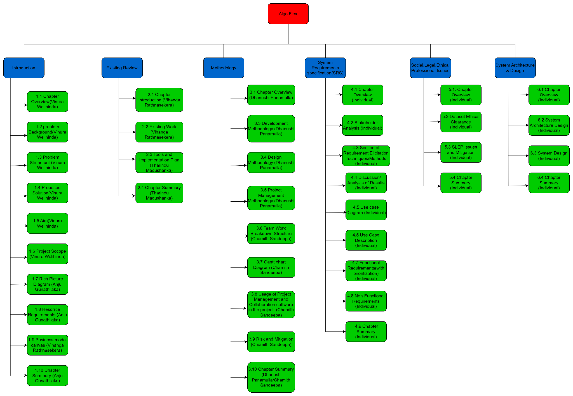

Figure : Team Work Breakdown Structure (WBS)

**3.7 Gantt chart diagram**

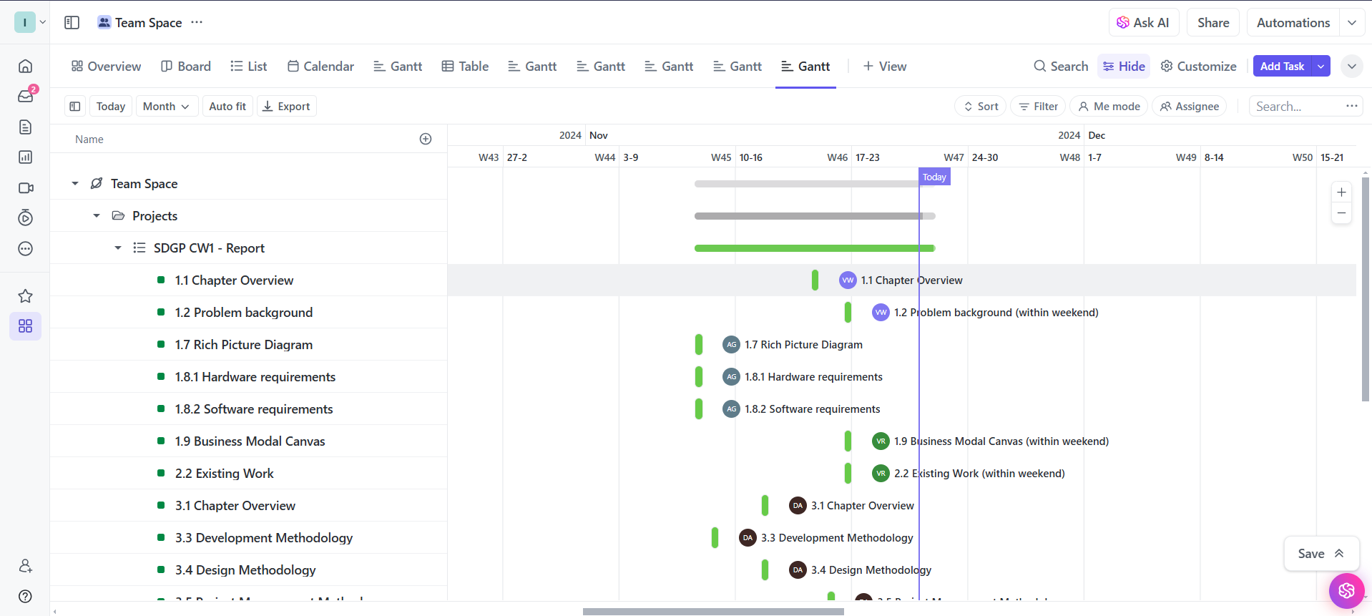

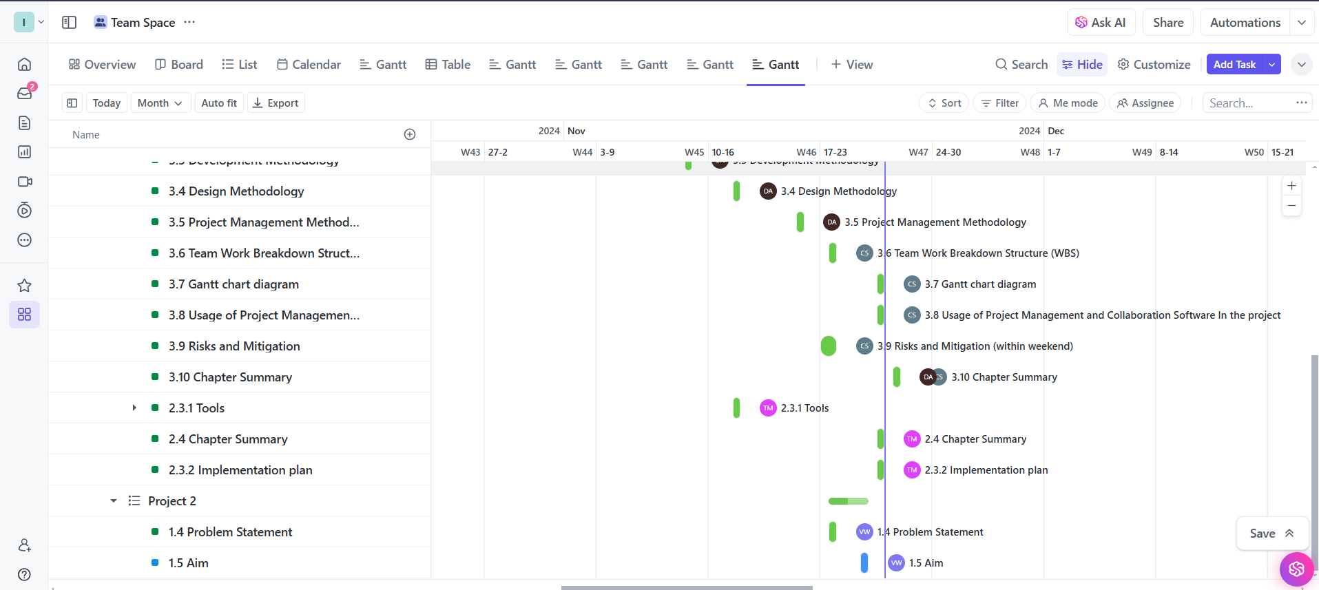

Figure : Gantt chart diagram

**3.8 Usage of Project Management and Collaboration Software In the project**

In here we used the ClickUp app as our project management software.

2024/11/07

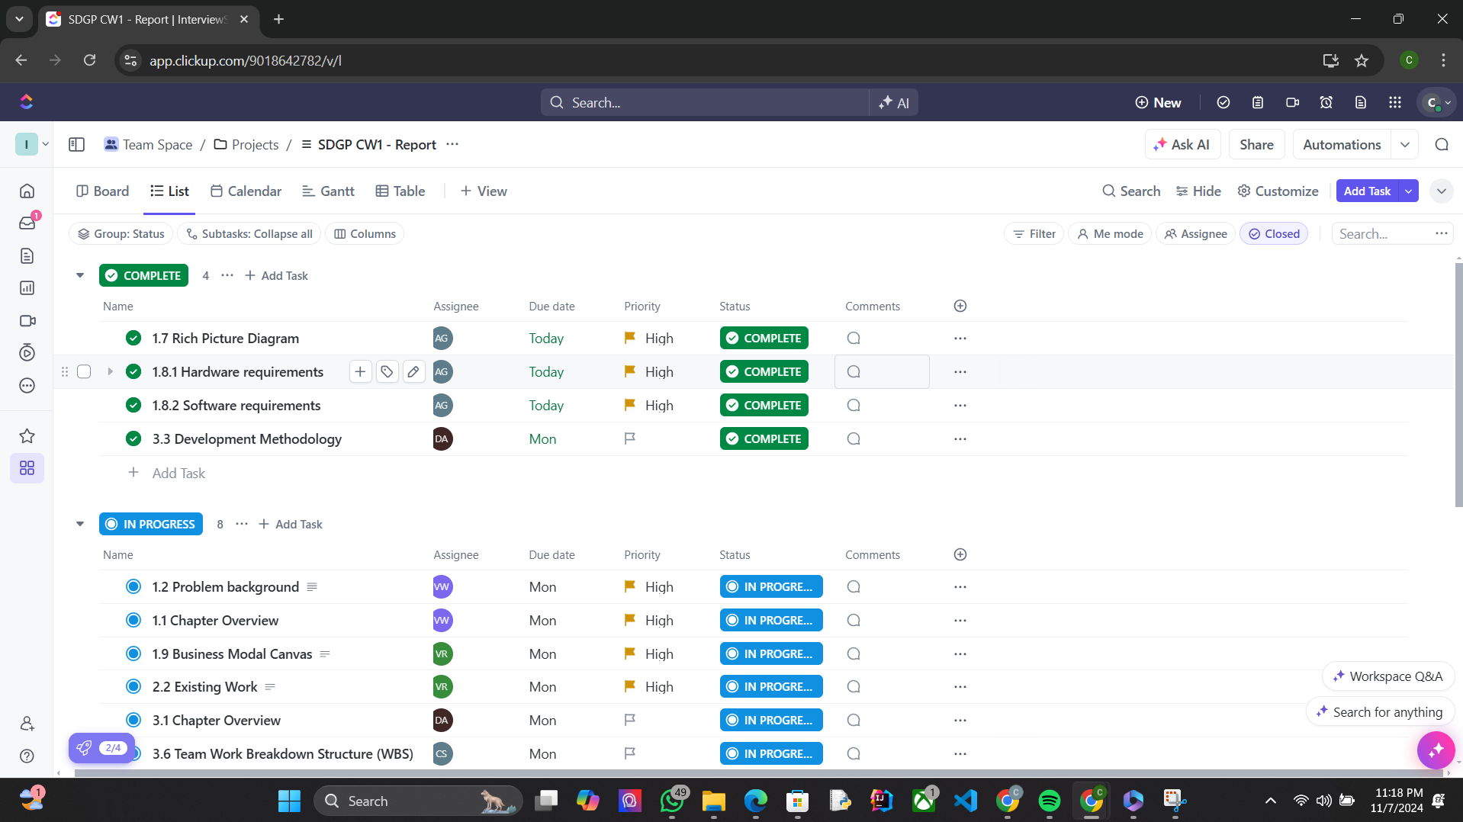

Figure : Usage of Project Management and Collaboration Software In the project - 1

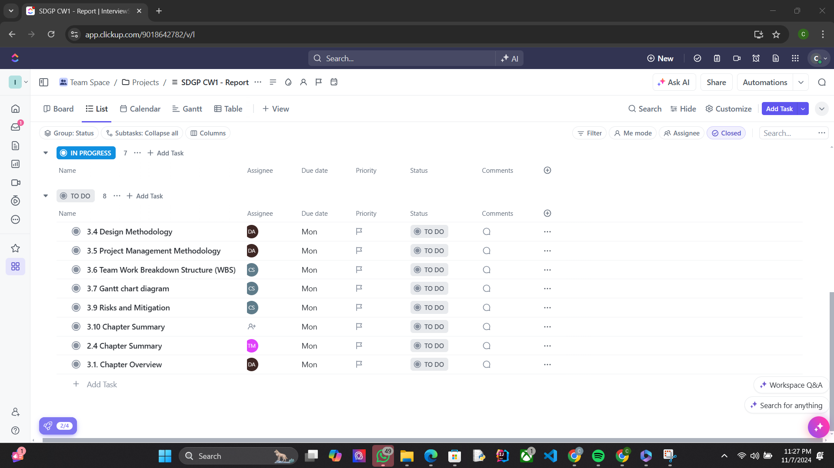

Figure : Usage of Project Management and Collaboration Software In the project - 2

2024/11/20

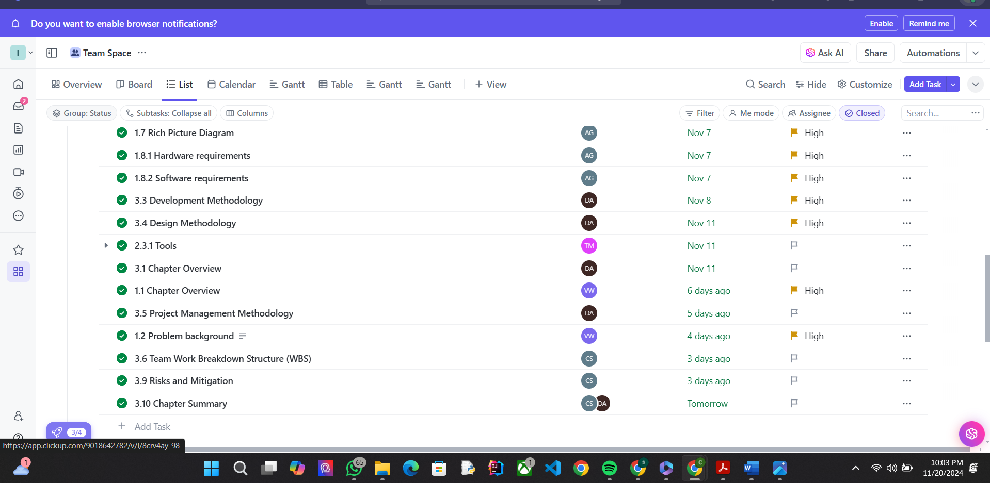

Figure : Usage of Project Management and Collaboration Software In the project - 3

Google Meet was the most often used platform for collaboration, however Microsoft Teams and Zoom was occasionally used as well.

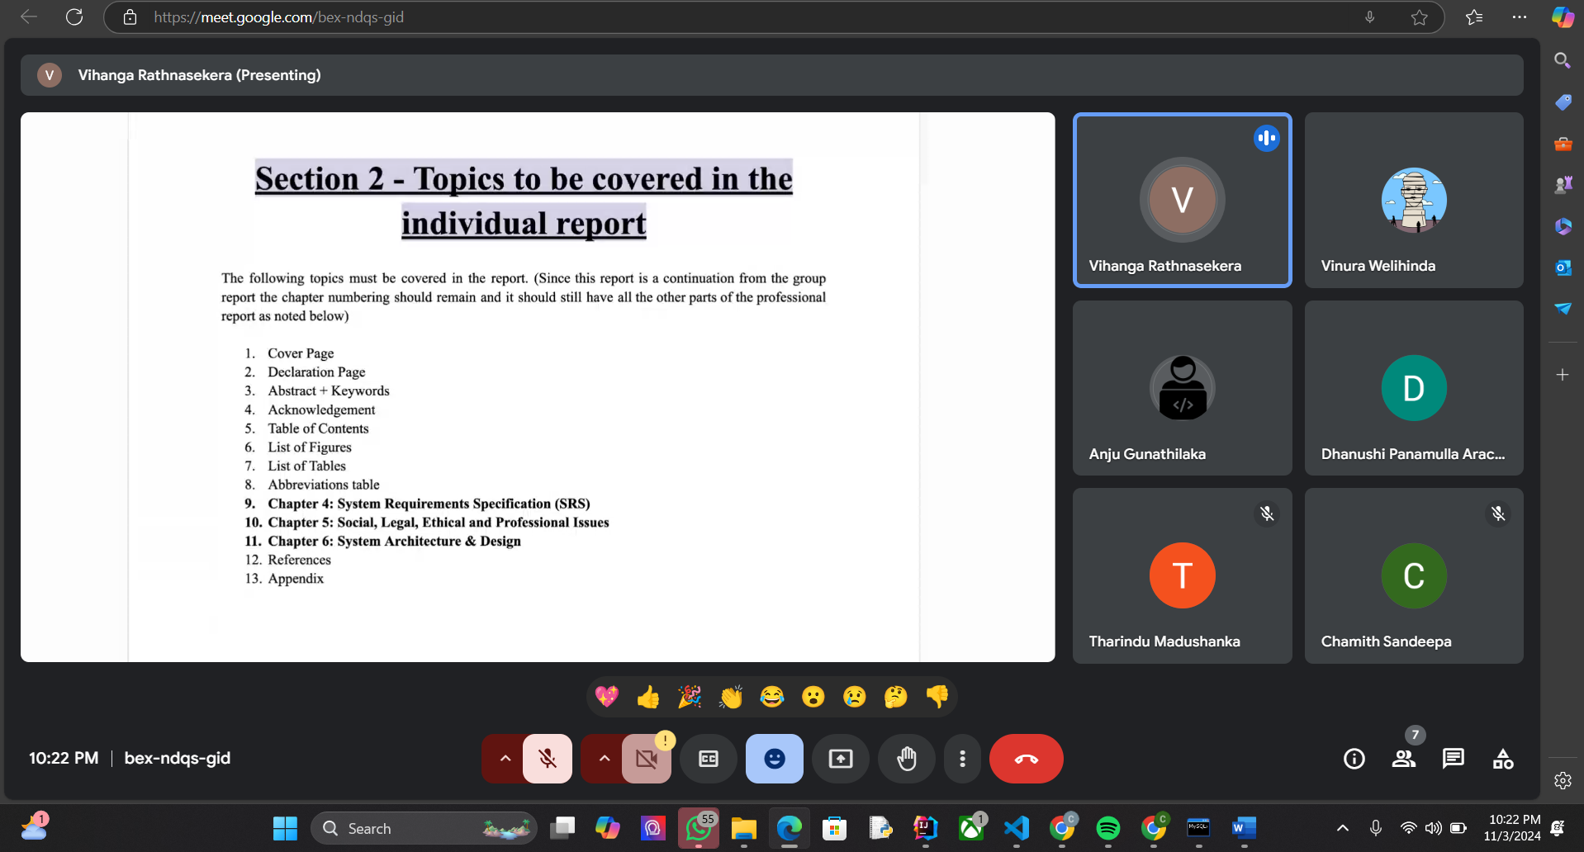

Figure : Group meeting 01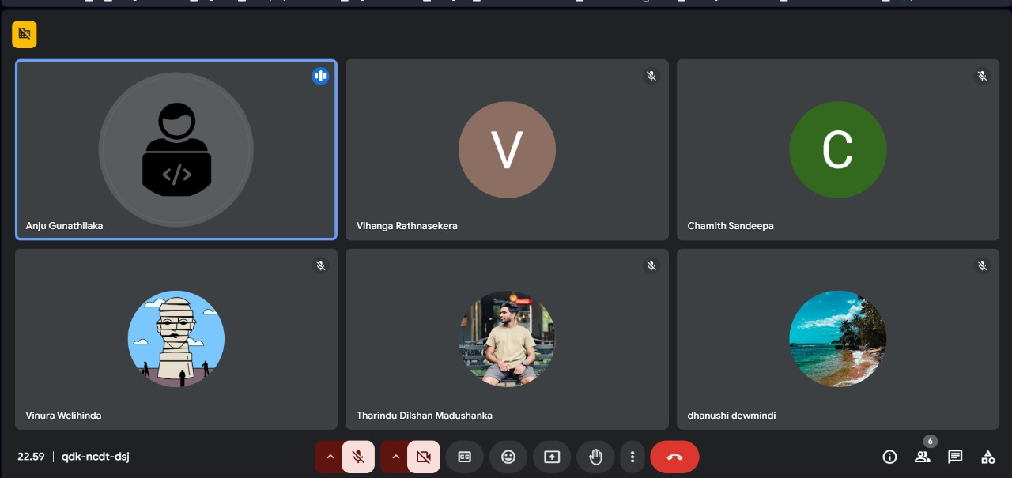

Figure : Group meeting 01

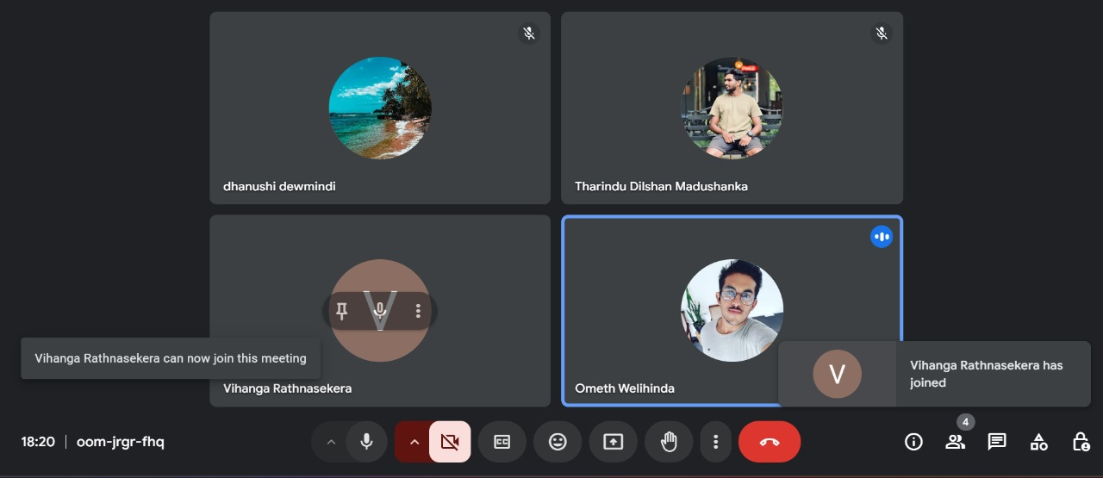

Figure : Group meeting 03

Figure : Group meeting 04

Figure : Group meeting 05

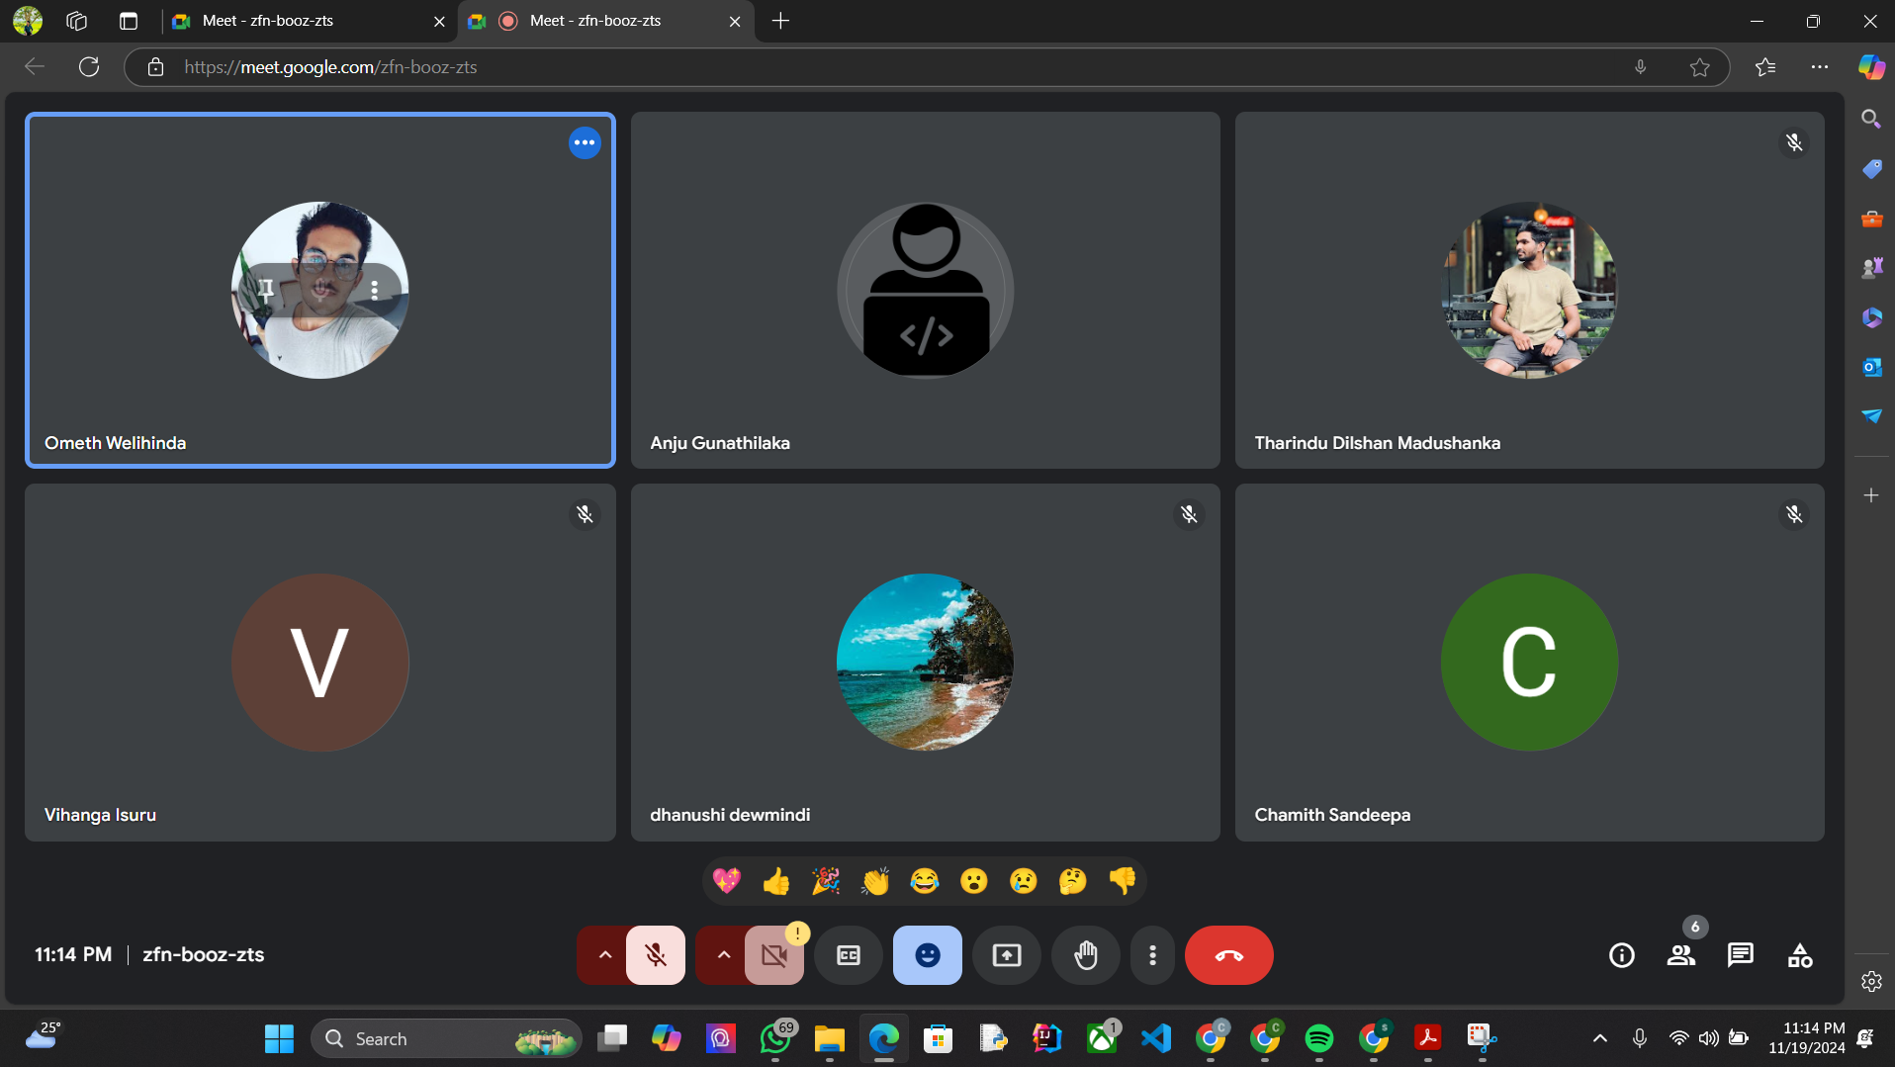

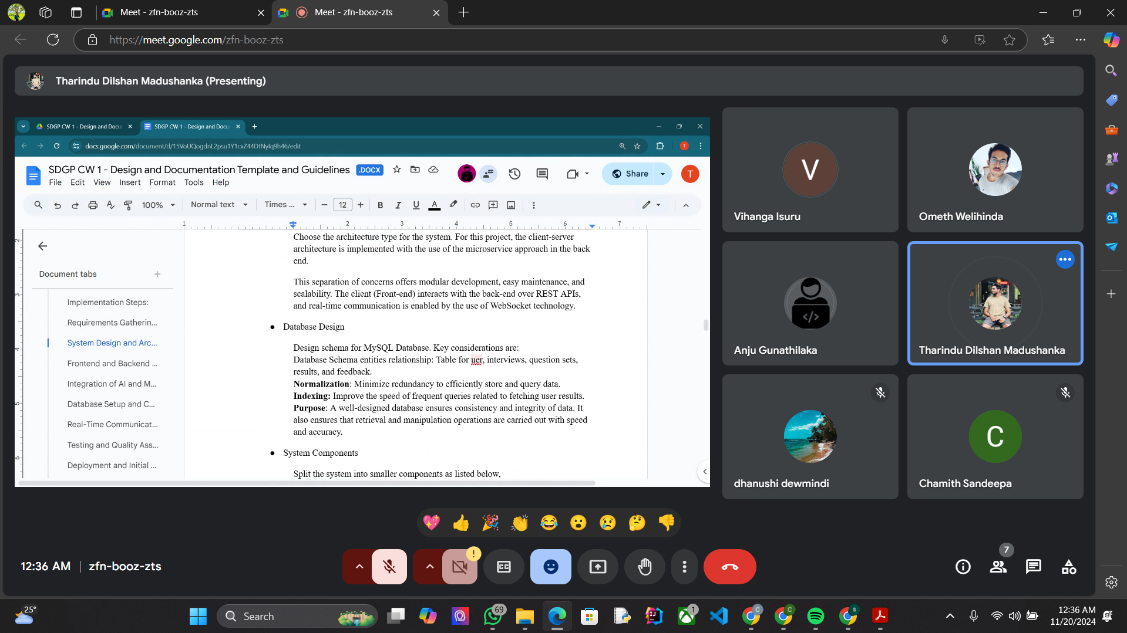

Figure : Group meeting 06

Weekly team meetings log

|  |  |  |  |  |  |  |
| --- | --- | --- | --- | --- | --- | --- |
| No | Date and Time | Mode(online/physical) | Venue | Incharge | What we discuss | Participation |
| 01 | 09th of October 2024 | Online | Google Meet | Group members only | Talked abut more ideas and tried to confirm an best idea and fill the form for group finalizations. | 6/6 |
| 02 | 14th of October 2024 | Online | Google Meet | Group members only | After talking, we put the best ideas in a one document and prepared for the feedback session. | 6/6 |
| 03 | 15th of October 2024 | Online | Microsoft teams | Mr.Suresh | Got a feedback on our group members ideas and pitch two ideas from that and also pointed out the shortcomings. | 6/6 |
| 04 | 24th of October 2024 | Physical | 3lA | Mr.Suresh | Finalized one of the two that had been pitched earlier and gave an idea about technical side of it. | 6/6 |
| 05 | 29th of October 2024 | Physical | 2LA | Group members only | After dividing the work among the members of the group, the group proposal was completed successfully. | 6/6 |
| 06 | 30th of October 2024 | Online | Zoom | Group members only | Submit the group proposal document after suggesting a name for the project. | 6/6 |
| 07 | 04th of November 2024 | Online | Google Meet | Group members only | After collecting the questions needed to create the google form related to a survey and finished making it. | 6/6 |
| 08 | 06th of November 2024 | Online | Google Meet | Group members only | Discuss solution for the during a feedback session conducted by Mr.Suresh sir, shown a problem with our idea. | 6/6 |
| 09 | 15th of November 2024 | Online(Supervisor session) | Google Meet | Group members only | Supervisor not attended the session due to the power cut. | 6/6 |
| 1o | 19th of November | Online | Microsoft teams | Mr.Mithushan | Considering all the amount that has been done so far in project and given a good feedback and gives the instruction for the LLAMA. | 6/6 |
| 11 | 19th of November | Online | Google Meet | Group members only | Discuss and check the implementation plan again. | 6/6 |

Table : Weekly team meetings log

**3.9 Risks and Mitigation**

**Eg:**

|  |  |  |  |
| --- | --- | --- | --- |
| **Risk Item** | **Severity** | **Frequency** | **Mitigation Plan** |
| Lack of availability of datasets and resources. | High | Moderate | Keep an extensively documented repo of easily accessible statics and resources for easy access and sharing, look for partnership between researchers and businesses, and proactive engagement with specialists. |
| A heavy workload because of the consequential exams and submissions. | Moderate | High | Manage all work and during work according to the timetables and targets. |
| Lack of technical and procedural knowledge. | High | Moderate | Gather up research papers, perform in-depth studies and consult specialists. Keep in touch with professionals. Carry out the appropriate research and employ web tools to learn new things all the time. |
| Overdue tasks and missing deadlines because of the project’s complexity. | High | Moderate | In this case, priority setting and progress monitoring. Often, as a result, designating more resources when required, was the main condition to keep the communication lines. Open, coming up with realistic time frames, careful planning, swifty communicating, and modifying the corresponding schedules thus in relation to a project's complexity are all significant. |

Table : Risks and Mitigation

**3.10 Chapter Summary**

This chapter describes the detailed methodologies followed for the development of AI-powered interview preparation and candidate assessment platforms. Emphasis is placed on the adaptation of Agile Development, Object Oriented Analysis and Design, and Structured project management to ensure flexibility, modularity, and structured project management to ensure flexibility, modularity, and scalability through the project management to ensure flexibility, modularity, and scalability throughout the project life cycle. These methodologies are important in accommodating dynamic requirements, fostering user-centered development, and facilitating advanced AI functions such as voice analysis, body language assessment, automated feedback, and dynamic question generation. Among these is the Agile development methodology, which has an iterative approach where the project evolves incrementally through sprints.

Each sprint focuses on specific features and ensures thorough development, testing, and refinement before it is included in the larger system. The flexibility of Agile makes it very suitable for an AI project like this where new models or techniques could be included without hindering the overall framework. Regular feedback loops with users ensure the platform does not lose sight of real-world needs, while the continuous improvement cycle minimizes risks and improves the functionality of the overall system. OOAD provides the foundation for designing the platform by guaranteeing modularity, scalability, and maintainability. By encapsulating complex functionalities such as voice and body language analysis into independent objects, the methodology simplifies testing, debugging, and future upgrades.

The use of layered architecture enhances the design by dividing the system into distinct layers responsible for user interaction, business logic, and data management. This approach caters to adding new features or updates with minimal effect on other already integrated components and provides an easy path for transition into microservices, allowing ease of future development. Finally, Technical development is complemented by project management methodologies, thus, task tracking and collaboration are done with the implementation of Agile principles using tools like ClickUp, GoogleMeet, Microsoft Teams, and Zoom. These tools facilitate effective sprint planning, resource allocation, and communication to ensure timely delivery of project milestones while overcoming the geographical barriers each team member had. A work breakdown structure insurers clearly and visually represents the project timeline, Indicating key phases and milestones.

Risk management strategies will also be developed to cope with issues like dataset availability, workload balancing, and technical gaps. It establishes a strong framework, in conclusion, for the implementation of the AI-powered platform. The incorporation of Agile methodology, OOAD, and Structures project management into the project strikes a balance between flexibility and adaptability on one side, and structured development on the other. Together, these provide a very basic basis for developing a user-oriented, scalable, and maintainable platform, catering to the needs of both job seekers and employers.

**References**

HireVue, 2024. *Video Interview Platform | Virtual Interview Software*. [online] Available at:<https://www.hirevue.com/platform/online-video-interviewing-software> [Accessed 15 November 2024].

BarRaiser, 2024. Experience smarter interviewing with BarRaiser. [online] Available at:<https://www.barraiser.com> [Accessed 15 November 2024]

Big Interview, n.d. *Learn how to ace your interview*. Available at:<https://www.biginterview.com> [Accessed 17 November 2024].

.Mohan, J., Vasamsetty Chandra Sekhar and Gupta, R. (2024). *Algorithms in Advanced Artificial Intelligence*. CRC Press.[Accessed 12 November 2024].

‌Bishop, C.M., 2006. *Pattern Recognition and Machine Learning*. New York: Springer.[Accessed 14 November 2024].

Goodfellow, I., Bengio, Y., and Courville, A., 2016. *Deep Learning*. Cambridge: MIT Press.[Accessed 14 November 2024].

Russel, S.J. and Norvig, P., 2020. *Artificial Intelligence: A Modern Approach*. 4th ed. Harlow: Pearson Education. [Accessed 17 November 2024].[Accessed 15 November 2024]..

Ullman, J.D. and Widom, J., 2020. *A First Course in Database Systems*. 4th ed. London: Pearson. [Accessed 17 November 2024].

Thomas, J. and Verma, P., 2023. Application of Natural Language Processing in Recruitment Platforms. *International Journal of Advanced Computing*, 37(2), pp.112–127. [Accessed 18 November 2024].

Binns,R..,2018. Fairness in Machine Learning: Lessons from Political Philosophy.Proceeding of the 2018 Conference on Fairness,Accountability, and Transparency(FAT),[online] pp. 149-159.Available at: <https://doi.org/10.1145/3287560.3287600> [Accessed 18 Nov.2024]

Shneiderman, B., 2020. *Human-Centered Artificial Intelligence: Reliable, Safe & Trustworthy*. *International Journal of Human-Computer Interaction*, 36(6), pp.495–504. Available at: <https://doi.org/10.1080/10447318.2020.1741118> [Accessed 18 Nov.2024]

Floridi, L. and Cowls, J., 2019. *A Unified Framework of Five Principles for AI in Society*. *Harvard Data Science Review*, 1(1). Available at: [https://doi.org/10.1162/99608f92.8cd550d1.](https://doi.org/10.1162/99608f92.8cd550d1%5BAccessed)  [Accessed 18 Nov.2024 ]

LinkedIn,2024. Professional Insights on Hiring Trends.[online] Available at: <https://www.linkedin.com/hiring-solutions> [Accessed 17 Nov.2024]